#### Description: Description: http://mcet.in/mcet_alpha/images/logo.jpg Description: Description: http://3.bp.blogspot.com/-jc9s0jwkiHQ/UFEx20uanCI/AAAAAAAABrU/ac-5q1DwvEM/s1600/anna_university_logo.png PORTABLE SELF-ASSESSMENT AUDIOMETER USING RASPBERRY PI

**MINI PROJECT REPORT**

Submitted by

### NAME ROLL NO

**ADHIL.M 727622BEC114**

**PRANESH .S 727622BEC018**

**NAVEEN.S 727622BEC110**

Under the guidance of

##### Mr.A.Shafeek,M.E.,

In partial fulfillment off the requirement for the award of

#### BACHELOR OF ENGINEERING

**In**

## ELECTRONICS AND COMMUNICATION ENGINEERING

**Dr. MAHALINGAM COLLEGE OF ENGINEERING AND TECHNOLOGY**

**An Autonomous Institution Affiliated to ANNA UNIVERSITY CHENNAI – 600 025**

#### MAY-2024

Dr. MAHALINGAM COLLEGE OF ENGINEERING AND TECHNOLOGY, POLLACHI -642 003

##### (An Autonomous Institution Affiliated to Anna University, Chennai - 600 025)

# BONAFIDE CERTIFICATE

Certified that this Mini project report titled **“PORTABLE SELF-ASSESSMENT AUDIOMETER USING RASPBERRY PI”** is the bonafide work of

### NAME ROLL NO

**ADHIL.M 727622BEC114**

**PRANESH .S 727622BEC018**

**NAVEEN.S 727622BEC110**

who carried out the mini project under my supervision.

|  |  |
| --- | --- |
| **Dr.R.Sudhakar,M.E.,Ph.D**  **HEAD OF THE DEPARTMENT**  Department of ECE  Dr. Mahalingam College of Engineering and Technology  Pollachi- 642003 | **Mr.A.Shafeek M.E., AP(SS)**  **SUPERVISOR**  Department of ECE  Dr. Mahalingam College of  Engineering and Technology Pollachi- 642003 |

Submitted for the Autonomous End Semester Mini Project Examination held on

## INTERNAL EXAMINER EXTERNAL EXAMINER

Dr. MAHALINGAM COLLEGE OF ENGINEERING AND TECHNOLOGY, POLLACHI -642 003

##### (An Autonomous Institution Affiliated to Anna University, Chennai - 600 025)

# TECHNOLOGY READINESS LEVEL (TRL) CERTIFICATE

**Project Title:** Portable Self-Assessment Audiometer Using Raspberry Pi

**Course Code:** 19ECPN6401- Mini Project

### NAME ROLL NO

**ADHIL.M 727622BEC114**

**PRANESH .S 727622BEC018**

**NAVEEN.S 727622BEC110**

**Guide Name: Mr.A.Shafeek M.E., AP(SS)/ECE**

##### Technology Readiness Level* (TRL) of this Project: TRL 06

**Prototype System Verified** (System/process prototype demonstration in an operational environment)

#### SIGNATURE OF THE GUIDE HOD

**INTERNAL EXAMINER EXTERNAL EXAMINER**

(*Refer to TRL Definition and for projects, Minimum TRL should be 4)

#### ACKNOWLEDGEMENT

We wish to express our sincere thanks to all who have contributed to do this project through their support, encouragement and guidance.

We extend our gratitude to our management for having provided us with all facilities to build my project successfully. We express our sincere thanks to our honourable Secretary, **Dr.C.Ramaswamy, M.E., Ph.D., F.I.V.,** for providing the required amenities.

We take this opportunity to express our deepest gratitude to our principal **Dr.P.Govindhasamy, M.Tech., Ph.D.,** who provide suitable environment to carry out the project.

We express our extreme gratefulness to **Dr.R.Sudhakar, M.E., Ph.D.,** Professor and Head of the department of Electronics and Communication Engineering, for his constant support and encouragement.

We wish to express our deep sense of gratitude and thankfulness to my project guide **Mr.A.Shafeek,M.E.,** for the valuable suggestion and guidance offered during the course of the project.

Finally, we are committed to place our heartfelt thanks to all those who had contributed directly and indirectly towards the success of the completion of this project.

## PORTABLE SELF-ASSESSMENT AUDIOMETER USING RASPBERRY PI

## ABSTRACT

People with hearing impairments often face irreversible damage. To determine the extent of hearing loss across different frequencies in each ear, a hearing screening test is used. However, traditional audiometers require an audiologist to conduct the test, which can be time- consuming and expensive for the individual. This study aims to create a new portable audiometer for self-assessment of hearing.

The portable audiometer consists of a computer, Raspberry Pi 3 B+, patient response button, and headphones. Sound signals are delivered to the patient through the headphones, and the patient responds using the left mouse button. Based on the patient's responses, an automatic audiogram is generated, showing the relationship between frequency and intensity, which indicates the volume of sound pressure.

The results, including the audiogram and raw data, are saved in CSV files named with the time and date of the test. A familiarization procedure is employed to help the hearing- impaired individual understand and perform the response task. The efficient Hughson Westlake procedure, which is less time-consuming, is implemented in Python, a popular open-source programming language, to obtain the audiogram. Using Python helps reduce software development costs.

#### BATCH 08

ADHIL.M - 727622BEC114 PRANESH .S - 727622BEC018 NAVEEN.S - 727622BEC110

#### SIGNATURE OF THE SUPERVISOR

Mr.A.Shafeek M.E., AP(SS)/ECE

Department of ECE

Dr. Mahalingam College of Engineering and Technology Pollachi- 64200

**TABLE OF CONTENTS**

**S.NO CHAPTER PG.NO INTRODUCTION I**

CERTIFICATE II

TECHNOLOGY READINESS LEVEL (TRL) CERTIFICATE III

ACKNOWLEDGEMENT IV

ABSTRACT V

TABLE OF CONTENT VI

LIST OF FIGURES IX

LIST OF TABLES XII

LIST OF ABBRIVATIONS XIII

1. INTRODUCTION 1
   1. INTRODUCTION 1
   2. MOTIVATION 3
   3. OVERVIEW 3
   4. OBJECTIVES 3
   5. PROBLEM STATEMENT 4

1.6. BENEFITS OF THE PROJECT 4

1. LITERATURE REVIEW 5
   1. INTRODUCTON 5
2. HEARING LOSS 8
   1. INTRODUCTION 8
   2. ANATOMY OF THE EAR 8
   3. PREVALENCE OF HEARING LOSS 9
   4. CAUSES AND RISK FACTORS 9
   5. TYPES OF HEARING LOSS 10
   6. SYMPTOMS OF HEARING LOSS 11

3.7 STAGES OF HEARING LOSS 11

1. SELF-ASSESSMENT AUDIOMETER 12
   1. INTRODUCTION 13
   2. PORTABLE AUDIOMETER UTILIZING RASPBERRY PI 13
   3. PORTABLE AUDIOMETER (RASPBERRY PI) 14

VS MOBILE HEARING TEST

* 1. SELF-ASSESSMENT AUDIOMETER FOR TESTING: 15

POSSIBLE AND NOT POSSIBLE SCENARIOS

* 1. EXISTING VS PROPOSED SELF-ASSESSMENT AUDIOMETERS 16

1. PURE TONE AUDIOMETER 18
   1. INTRODUCTION 18
   2. PURPOSE OF PTA 18
   3. TYPES OF TESTING 19
   4. AUDIOGRAM 20
   5. AUDIOGRAM CONFIGURATION 22
   6. LIMITATIONS 22
   7. APPLICATION 23
   8. FEATURES 23

|  |  |  |
| --- | --- | --- |
| **6** | **IMPLEMENTATION OF HARDWARE MODULES** | **24** |
|  | 6.1 INTRODUCTION | 24 |
|  | 6.2. BLOCK DIAGRAM | 24 |
|  | **COMPONENT DESCRIPTION** |  |
|  | 6.3. RASPBERRY PI | 25 |
|  | 6.2.1. FEATURES OF RASPBERRY PI | 25 |
|  | 6.2.2. RASPBERRY PI GPIO’S PIN | 26 |
|  | 6.2.3. RASPBERRPY PI PIN DETAILS | 27 |
|  | 6.4. RASPBERRY PI CASE | 28 |
|  | 6.5. MOUSE | 28 |
|  | 6.6. HEADPHONE | 29 |
|  | 6.6.1. TDH 49 HEADPHONE CHARACTERISTICS AND USAGE | 30 |
|  | 6.7. ETHERNET CABLE | 30 |
|  | 6.8. POWER SUPPLY | 31 |

1. **SOFTWARE IMPLEMENTATION 32**
   1. INTRODUCTION 32
   2. RASPBERRY PI OS (RASPBIAN) 32
   3. VNC: REMOTE ACCESS A RASPBERRY PI 33
   4. PYTHON ON RASPBERRY PI: THONNY EDITOR 34
2. **VALIDATION AND FEEDBACK: MEETING WITH ENT DOCTOR 35**
   1. INTRODUCTION 35
   2. DISCUSSION WITH DR. B. HARSHA 35
   3. RECOMMENDATION TO MEET AN AUDIOLOGIST 36
   4. DISCUSSION WITH THE ENT DOCTOR 36
   5. TESTING THE SELF-ASSEMBLED PURE TONE AUDIOMETER 37
   6. FEEDBACK AND CONCLUSION 37
3. **MEETING WITH AUDIOLOGIST BALACHANDRAN 38**
   1. INTRODUCTION 38
   2. MEETING WITH AUDIOLOGIST BALACHANDRAN 38
   3. PROJECT DISCUSSION AND RECOMMENDATIONS 39
   4. QUESTIONS AND AUDIOMETER INSIGHTS 39
   5. GUIDANCE AND LEARNING 40
   6. KEY FEEDBACK FROM AUDIOLOGIST 40
   7. EXPLORATION AND FUTURE SCOPE 41
   8. CONCLUSION 41
4. **RESULTS 42**
   1. INTRODUCTION 42
   2. TESTING OF FINAL WORKING MODEL 42
   3. WORKING MODEL 43
   4. RESULT ANALYSIS 44
5. **CONCLUSION 48**
6. **BIBLIOGRAPHY 49**
7. **APPENDICES 51**

**PLAGIARISM REPORT 58**

## LIST OF FIGURES

|  |  |  |  |
| --- | --- | --- | --- |
| **S NO** | **FIGURES** | **TOPIC** | **PAGE NO** |
| 1. | 1.1 | PURE TONE AUDIOMETRY (PTA) | 2 |
| 2. | 3.2 | ANATOMY OF THE EAR | 8 |
| 3. | 3.5 | TYPES OF HEARING LOSS | 10 |
| 4. | 3.6 | SYMPTOMS OF HEARING LOSS | 11 |
| 5. | 3.7 | STAGES OF HEARING LOSS | 11 |
| 6. | 4.1 | SELF-ASSESSMENT AUDIOMETER | 13 |
| 7. | 4.3.1 | PORTABLE AUDIOMETER | 14 |
| 8. | 4.3.2 | MOBILE HEARING TEST | 14 |
| 9. | 4.5.1 | PORTABLE SELF ASSESSMENT AUDIOMETER | 16 |
| 10.. | 4.5.2. | AUDIOMETER | 16 |
| 11. | 5.1. | PURE TONE AUDIOMETER | 18 |
| 12 | 5.3. | TYPES OF TESTING | 19 |
| 13 | 5.4. | AUDIOGRAM | 20 |
| 14. | 5.4.1 | Audiogram Sheet | 21 |

|  |  |  |  |
| --- | --- | --- | --- |
| 15. | 5.5. | AUDIOGRAM CONFIGURATION | 22 |
| 16. | 6.2. | Block Diagram | 24 |
| 17 | 6.3.1 | RASPBERRY PI | 25 |
| 18. | 6.3.2 | PIN DESCRIPTION OF RASPBERRY PI | 26 |
| 19. | 6.3.3 | RASPBERRY PI GPIO’S PIN LAYOUT | 27 |
| 20. | 6.3.4 | RASPBERRY PI GPIO | 27 |
| 21. | 6.4 | RASPBERRY PI CASE | 28 |
| 22. | 6.5 | MOUSE | 29 |
| 23. | 6.6 | HEADPHONE | 29 |
| 24. | 6.7 | ETHERNET CABLE: | 31 |
| 25. | 6.8 | POWER ADAPTER | 31 |
| 26. | 7.2 | INSTALLING RASPBIAN. | 32 |
| 27. | 7.2.1 | THE RASPBERRY PI DESKTOP. | 33 |
| 28. | 7.3 | VNC: REMOTE ACCESS TO A RASPBERRY | 34 |
| 29. | 7.4 | THONNY IDE | 34 |
| 30. | 8.2. | CONSULTING WITH THE DOCTOR | 41 |

|  |  |  |  |
| --- | --- | --- | --- |
| 31. | 9.2. | CONSULTING WITH THE AUDIOLOGIST | 44 |
| 32 | 9.3. | AUDIOMETRY TEST | 45 |
| 33. | 9.6. | AUDITIVO AUDIOMETER | 46 |
| 34. | 10.3. | OVERALL INITIALIZATION PURE TONE AUDIOMETER | 50 |
| 35. | 10.4.1. | PYTHON CODE IN THONNY IDE | 50 |
| 36. | 10.4.2. | INSTRUCTION OF THE PROJECT | 51 |
| 37. | 10.4.3. | PATIENT RESPONSE OF THE  AUDIOMETER | 51 |
| 38. | 10.4.4. | OUTPUT OF THE AUDIOGRAM CHART | 52 |
| 39 | 10.4.5. | RESULT AUDIOGRAM CHART | 52 |
| 40 | 10.4.6. | PORTABLE SELF ASSESSMENT AUDIOMETER | 53 |
| 41 | 11 | PLAGIARISM REPORT | 55 |

## LIST OF TABLES

|  |  |  |  |
| --- | --- | --- | --- |
| **S NO** | **TABLE** | **TOPIC** | **PAGE NO** |
| 1. | 3.7 | Stages of hearing loss | **12** |
| 2. | 4.3 | Portable Audiometer (Raspberry Pi) Vs Mobile Hearing Test | **15** |
| 3. | 4.7 | Existing vs proposed self-assessment audiometers | **16** |
| 4, | 10.4 | Result analysis | **53** |

## LIST OF ABBRIVATIONS

1. HA - Hearing aid
2. SNHL - Sensorineural hearing loss
3. WNL - Within normal limits
4. AU - Both sides (ears)
5. AS - Left
6. AD - Right
7. BC - Bone conduction
8. AC - Air conduction
9. PTA - Pure-tone average
10. UCL - Uncomfortable loudness level
11. MCL - Most comfortable loudness level
12. HFA - High frequency average
13. HL - Hearing level
14. SRT - Speech reception threshold
15. SAT - Speech awareness threshold

## CHAPTER - 1 INTRODUCTION

#### INTRODUCTION

Hearing impairment is a widespread chronic condition affecting adults globally, especially as they age, particularly at frequencies exceeding 2000 Hz. According to the World Health Organization (WHO), approximately 466 million people worldwide are affected by hearing loss, with 75% residing in developing nations. Factors such as prolonged exposure to loud noises, aging, tumors, illnesses, and ototoxic medications contribute to hearing loss, which may occur alone or alongside tinnitus. Though not fatal, hearing loss can lead to depression, communication difficulties, decreased functional abilities, and social isolation. Detecting and treating hearing loss early is crucial to enhance the quality of life for older adults dealing with hearing impairment.

Research conducted in the United Kingdom found that individuals who identified their hearing loss early and consistently used hearing aids experienced greater benefits compared to those who delayed using hearing aids until later stages of the condition. Therefore, it is essential to conduct hearing screening tests in the early stages to minimize the impact of hearing loss on individuals' lives. Hearing levels are typically evaluated across frequency ranges centered at 125Hz, 250 Hz, 500 Hz, 1 kHz, 2 kHz, 4 kHz, and 8 kHz. Although the human hearing range is commonly stated as 20 to 20,000 Hz, variations can occur, especially at higher frequencies.

Audiometers are instruments used to assess hearing capacity, often employing pure tone audiometry (PTA) testing, where individuals respond to presented pure tones. Traditionally, audiologists administer these tests in soundproof booths, necessitating patient visits to clinics, which may be inconvenient, especially for elderly individuals with mobility issues. During the test, patients wear sound-isolating headphones, and tones ranging from 125 Hz to 8 kHz are played at different intensities to determine hearing thresholds. The intensity level is adjusted to reach the patient's threshold, following the Hughson Westlake ascending method. While traditional audiometers are precise, they are costly and time-consuming.

Advances in information and communication technology have led to the development of screening audiometers and portable hearing-test devices, offering improved efficiency and

cost-effectiveness. Various approaches, such as auto kits utilizing personal computers or portable audiometers with dedicated hardware units, have been devised to streamline the testing process. However, challenges such as equipment costs or the necessity for audiologist involvement persist.

The present study introduces a self-assessment hearing test aimed at being cost- effective, straightforward, and user-friendly. The goal was to develop a computer-based screening kit that individuals with minimal computer proficiency could easily utilize to conduct their own hearing tests. This proposed pure tone audiometry (PTA) system offers high portability and affordability, with the aim of broadening access to hearing screening.

.

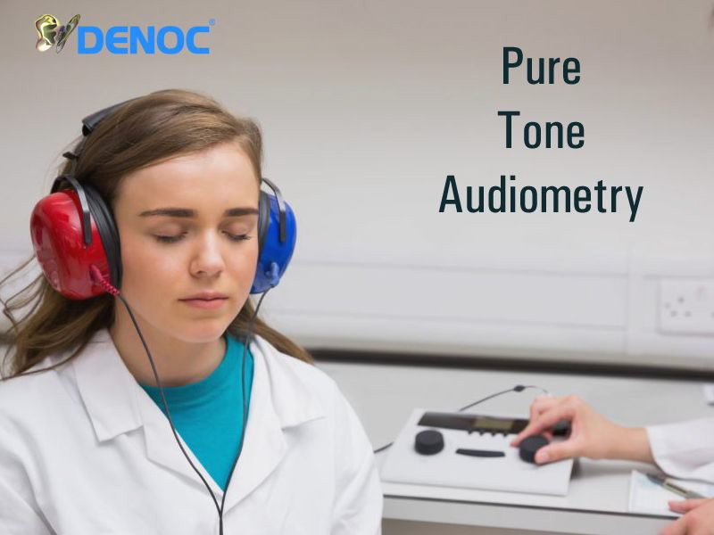

**Fig 1.1** Pure Tone Audiometry (PTA)

#### MOTIVATION

The motivation for developing the portable self-assessment audiometer arises from the need to overcome limitations of traditional testing methods. This includes improving accessibility, reducing costs, and enhancing convenience, especially for those in remote areas. By leveraging technology and affordability, the project aims to democratize hearing healthcare, empowering individuals to monitor their hearing health easily and effectively. The device's user-friendly design and data storage capabilities further support its role in facilitating early detection and intervention, ultimately improving outcomes and quality of life for individuals with hearing impairments.

#### OVERVIEW

The project focuses on developing a Portable Audiometer for Hearing Self-Assessment, aiming to address the challenges posed by traditional audiometry testing in terms of accessibility, cost, and time consumption. Leveraging Raspberry Pi, Python programming language, and audio hardware, the audiometer enables individuals to assess their hearing independently, offering a cost-effective and user-friendly solution.

The audiometer comprises hardware components including Raspberry Pi 3 B+, a mouse for user interaction, and headphones for audio output. Raspberry Pi serves as the core computing platform, generating pure tone signals across different frequencies and intensity levels. Python programming language is utilized for software development, managing signal generation, user interaction, response recording, and data analysis.

During the testing procedure, the audiometer conducts a series of tests for both ears, playing pure tone signals at varying frequencies and intensity levels. Users respond to the audible tones by clicking the mouse button. The modified Hughson Westlake procedure is employed to adjust signal intensity based on user response

#### OBJECTIVES

The project endeavors to create a Portable Audiometer for Hearing Self-Assessment, leveraging Raspberry Pi, Python programming, and audio hardware. Its goal is to address the drawbacks of traditional audiometry by providing a budget-friendly, easy-to-use solution for self-directed hearing evaluation. By producing pure tone signals and integrating a modified version of the Hughson Westlake procedure, individuals can react to audible tones by clicking the mouse.

The gathered data will undergo analysis to ascertain hearing thresholds and produce audiograms, visually depicting hearing levels. Ultimately, the aim is to improve the accessibility of hearing screening, facilitating early identification and management of hearing impairment

#### PROBLEM STATEMENT

Traditional audiometric testing methods present barriers to individuals seeking to assess their hearing health, including limited accessibility, high costs, and inconvenience. Particularly challenging for those in remote areas, these methods often result in delays in diagnosis and intervention. To address these issues, there is a pressing need for a portable self-assessment audiometer. This device must be affordable, user-friendly, and capable of providing accurate assessments without professional oversight. Additionally, it should offer convenient data storage and analysis for collaboration with healthcare professionals. The challenge is to design and implement a portable audiometer that democratizes access to hearing healthcare, empowering individuals to monitor and manage their hearing health effectively. It must be cost-effective, portable, easy to use, and capable of delivering accurate results, ultimately improving outcomes for individuals with hearing impairments.

## BENEFITS OF THE PROJECT

The project of developing a portable self-assessment audiometer offers several benefits:

* + 1. **Accessibility**: It provides easy access to hearing assessments for individuals, especially in remote areas where audiologists are scarce.
    2. **Cost-Effectiveness**: By utilizing affordable components and open-source software, it reduces the financial burden associated with traditional audiometric tests.
    3. **Convenience:** Users can conduct tests at their convenience, avoiding the need for scheduling appointments and traveling to clinics.
    4. **Early Detection:** Regular self-assessment allows for the early detection of hearing issues, leading to timely intervention and improved outcomes.
    5. **Empowerment:** It empowers individuals to take control of their hearing health by facilitating regular monitoring and self-management.
    6. **Portability**: The device's portability enables testing in various settings, including homes, schools, workplaces, and community centers.

## CHAPTER -2 LITERATURE REVIEW

#### 2.1 INTRODUCTION

This research paper addresses the need for accessible hearing health assessment methods. Traditional audiometry faces barriers like cost and accessibility. To overcome these, we explore a portable audiometer for self-assessment, utilizing Raspberry Pi technology. This innovation aims to empower individuals to monitor their hearing health independently, particularly benefiting underserved communities. Through rigorous testing, we aim to demonstrate the effectiveness of this solution in improving accessibility and inclusivity in hearing healthcare**.**

#### 2.2. METHODOLOGY

1. **“A NOVEL RASPBERRY PI-3 BASED PURE TONE AUDIOMETER AND VERIFICATION OF CALIBRATION WITH STANDARD SYSTEM”**

M.Dharani Kumar Chowdhary , Dr. C. Nagaraja , Dr. C. Sandeep Kumar Reddy , Dr.Srinivasarao Udara ,worked on “A novel raspberry pi-3 based pure tone audiometer and verification of calibration with standard system” In the present era, The Raspberry Pi-based audiometer utilizes a sound card and headphones to generate and present pure tones at various frequencies and intensities, mimicking a traditional audiometer. Users would indicate hearing the tones through a method not specified in the current summary (possibly a button press). A crucial aspect of this system is calibration, ensuring accurate results.

The study emphasizes verifying the Raspberry Pi system's calibration against a standard audiometer. This portable and potentially lower-cost solution holds promise for increasing access to hearing screenings in areas with limited resources. It might also be useful for individuals to monitor their hearing health at home, although a professional diagnosis remains essential.

#### “DEVELOPMENT OF HEARING SELF-ASSESSMENT PURE TONE AUDIOMETER”

Marwa Gargouri, Mondher Chaoui, and Patrice Wira present a pioneering study on the "Development of hearing self-assessment pure tone audiometer." Addressing the global prevalence of hearing loss and its consequential impact, the researchers propose an innovative solution to provide accessible and cost-effective hearing screening. Their portable audiometer integrates Raspberry Pi technology with a computer, patient response button, and headphones, allowing individuals to conduct self-administered hearing tests. By employing the Hughson Westlake procedure implemented in Python, the audiometer automatically generates audiograms based on patient responses. This approach aims to mitigate the time and cost burdens associated with traditional audiometry, particularly benefiting elderly and underserved populations. The study underscores the significance of early detection and intervention in managing hearing impairment while advancing accessibility to screening tools through innovative technology and open-source software.

1. **HEARTHAT? - AN APP FOR DIAGNOSING HEARING LOSS**

Silvia Figueira, Kevin Nguyen, and Shweta Panditrao's project, "HearThat? - An app for diagnosing hearing loss," showcased the transformative potential of smartphone applications in tackling healthcare obstacles. Their work aligns with the essence of our project, focusing on leveraging technology to enhance accessibility and efficiency in healthcare. By developing an app specifically designed for diagnosing hearing loss, they exemplify the innovative possibilities of mobile health solutions. This project underscores the relevance of incorporating smartphone-based tools into healthcare practices, emphasizing the importance of accessibility and ease of use in addressing medical challenges. Their insights contribute to the broader landscape of utilizing technology to empower individuals and improve healthcare outcomes.

1. **"PORTABLE AUDIOMETER FOR DETECTING HEARING DISORDER AT AN EARLY STAGE FOR CANCER PATIENTS**

In their work presented at the 2016 International Conference on Automatic Control and Dynamic Optimization Techniques, Ritu Rani and H.T. Patil introduced a "Portable audiometer for detecting hearing disorder at an early stage for cancer patients." This innovative device signifies a multifaceted approach to healthcare, emphasizing the significance of early detection

in managing health conditions. By focusing on cancer patients, the research addresses the often- overlooked aspect of hearing impairment resulting from cancer treatments or related complications. The development of a portable audiometer tailored to this specific demographic underscores the importance of personalized medical solutions and the integration of technology into healthcare delivery. This project likely involved the design and validation of a specialized diagnostic tool capable of early detection, thereby highlighting the intersection of medical research, technology, and patient care.

1. The conception of a software pure tone audiometer application by Marwa Gargouri, Mondher Chaoui, and Abdennaceur Kachouri represents a significant milestone in audiology research and technological innovation. Their work embodies a shift towards digital solutions for conducting pure tone audiometry, offering the potential to revolutionize the field by improving accessibility and reducing costs associated with traditional audiometers. By leveraging software and technology, their application not only enhances the efficiency and accuracy of hearing screening methods but also addresses the challenges faced by individuals with hearing impairments. Integrating their research findings into the literature review of your project could provide comprehensive insights into the development and application of software-based audiometry tools, further advancing the understanding and implementation of hearing assessment technologies.
2. Fei Chen and Shuai Wang explore the development of smartphone-based self- hearing diagnosis using hearing aids. Their research investigates the potential of leveraging smartphone technology to offer accessible and convenient methods for individuals to assess their hearing abilities. By integrating hearing aid functionality with smartphone applications, the study aims to provide users with real-time feedback on their hearing health, empowering them to proactively monitor and manage any changes in their auditory capabilities. The utilization of smartphones as diagnostic tools for hearing impairment holds promise in extending the reach of hearing healthcare services to broader populations, particularly those with limited access to traditional clinical resources. Chen and Wang's work contributes to the advancement of tele audiology and mobile health solutions, fostering greater independence and autonomy in managing hearing-related issues.

## CHAPTER – 3 HEARING LOSS

#### INTRODUCTION

Current approaches for evaluating hearing loss, like traditional audiometry, demand skilled personnel and specialized tools, rendering them slow, expensive, and out of reach for many. There's a demand for a portable and easy-to-use audiometer that empowers individuals to assess their own hearing, especially those with limited computer proficiency. Such a device should provide an affordable means for frequent monitoring of hearing health, boosting access to hearing care services and enriching the lives of those with hearing challenges.

## ANATOMY OF THE EAR

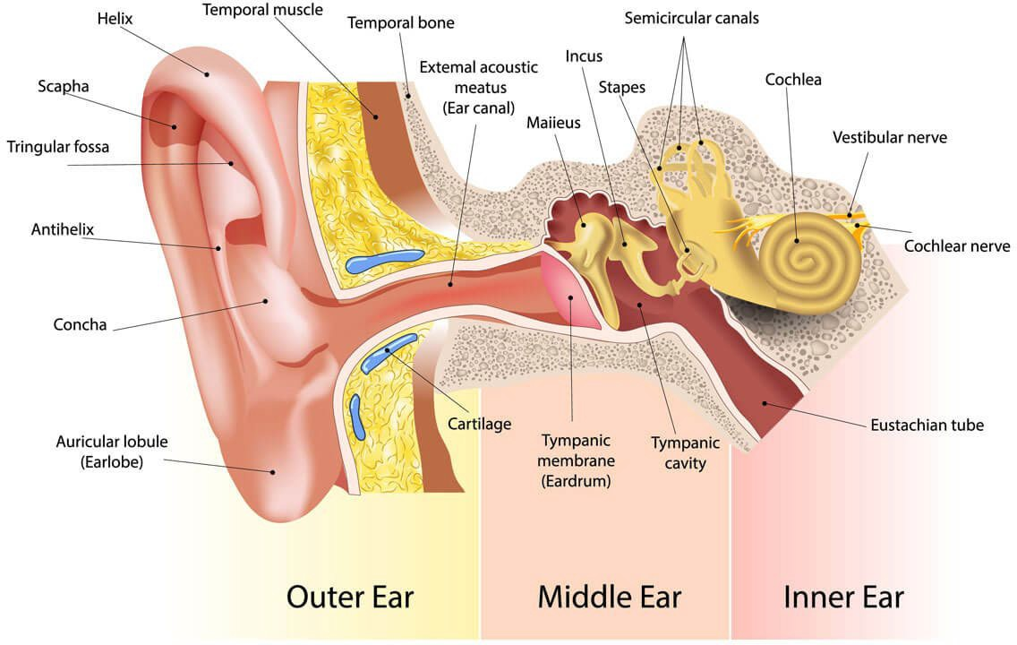

Fig 3.2 Anatomy of the Ear

The ear consists of three primary components: the external ear (comprising the pinna and ear canal), middle ear (consisting of the ossicles), and inner ear (housing the cochlea and vestibular system). Sound waves are captured by the pinna, then transmitted through the ear

canal to the eardrum. The eardrum vibrates in response, conveying these vibrations through the ossicles to the cochlea. Within the cochlea, numerous hair cells transform these vibrations into electrical signals, which are then relayed to the brain via the auditory nerve, allowing for auditory perception. Additionally, the inner ear's vestibular system plays a crucial role in maintaining equilibrium. Understanding the anatomical structure of the ear is essential for diagnosing and managing conditions affecting hearing and balance.

#### PREVALENCE OF HEARING LOSS:

Hearing loss is widespread, with statistics indicating its significant impact across different demographics:

* + 1. In India, over 63 million people (approximately 6% of the population) suffer from significant hearing impairment.
    2. Factors contributing to this include age, gender, socioeconomic status, and environmental conditions.
    3. Efforts to address this issue include awareness campaigns, early detection programs, and improvements in healthcare infrastructure.
    4. There remains a significant need for continued investment in accessible and affordable hearing healthcare services.

#### CAUSES AND RISK FACTORS

* + 1. Aging: Natural deterioration of auditory function over time.
    2. Genetics: Inherited predispositions to hearing loss.
    3. Noise Exposure: Prolonged exposure to loud noises.
    4. Ototoxic Medications: Certain medications that can damage hearing.
    5. Medical Conditions: Diabetes, cardiovascular disease, and ear infections.

#### TYPES OF HEARING LOSS

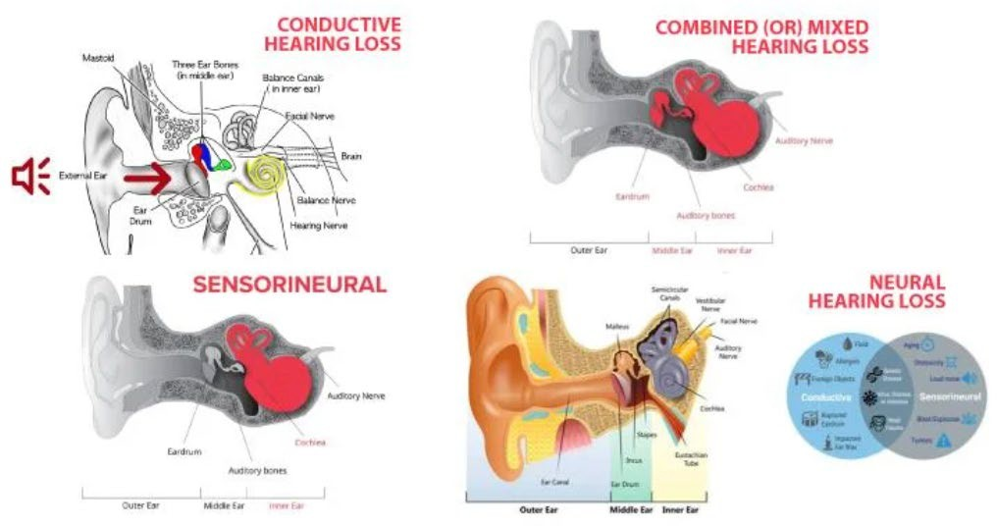

##### Fig 3.5. Types of Hearing Loss

* + 1. **Sensorineural Hearing Loss**:

This form of hearing impairment typically arises within the cochlea or inner ear and is often irreversible. A variety of factors, such as genetic predisposition, prenatal or childhood illnesses, specific medications, accidents leading to inner ear damage, or exposure to high levels of noise, can contribute to its development.

##### Conductive Hearing loss:

Conductive hearing loss occurs when there is an obstruction or malfunction in the transmission of sound to the inner ear, while the inner ear itself remains unaffected. This type of hearing loss may be temporary or permanent. Surgical procedures or the use of hearing aids can help mitigate the blockage, allowing sound to reach the inner ear.

##### Combined Hearing loss:

Mixed hearing loss encompasses aspects of both sensorineural and conductive hearing loss. It involves challenges related to both the inner ear and the transmission of sound. Treatment approaches may involve a blend of surgical interventions, hearing aids, or other customized strategies to address both forms of impairment.

* 1. **SYMPTOMS OF HEARING LOSS:**

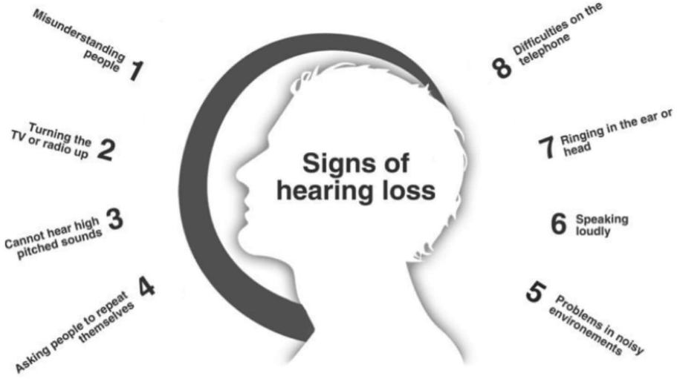

Fig 3.6. Symptoms of Hearing Loss

* + 1. Difficulty hearing speech, especially in noise.
    2. Asking for repetition frequently.
    3. Increasing volume on devices.
    4. Speech sounding unclear.
    5. Struggling with high-pitched sounds.
    6. Hearing ringing or buzzing.
    7. Experiencing ear discomfort.

#### STAGES OF HEARING LOSS

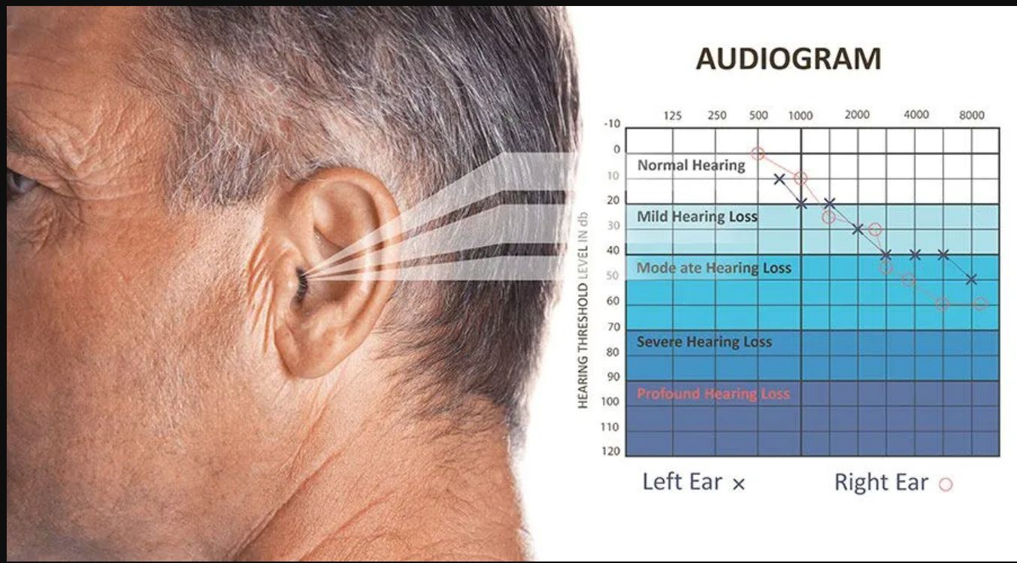

Fig 3.7. Stages of hearing loss

* + 1. **Normal Auditory Function (0-25 dB):** Adequate capacity to perceive faint sounds, whispers, and gentle speech with clarity and ease.
    2. **Mild Auditory Impairment (26-40 dB):** Challenges in discerning soft or distant speech, particularly amid noisy surroundings.
    3. **Moderate Auditory Impairment (41-55 dB):** Effort required to comprehend conversational speech, especially when background noise is present.
    4. **Moderately Severe Auditory Impairment (56-70 dB):** Struggles in grasping speech without external assistance, such as hearing aids.
    5. **Severe Auditory Impairment (71-90 dB):** Limited capability to comprehend speech without external amplification; reliance on sign language may be necessary
    6. **Profound Hearing Loss (>90 dB):** Very limited or no hearing without hearing aids or cochlear implants; heavily reliant on visual cues for communication.

|  |  |  |  |
| --- | --- | --- | --- |
| **SL.**  **NO.** | **STAGE** | **DESCRIPTION** | **THRESHOLDS (DB)** |
| **1.** | **NORMAL** | No significant impairment | 0-25 |
| **2.** | **MILD** | Difficulty with faint or distant speech | 26-40 |
| **3.** | **MODERATE** | Trouble with conversational speech | 41-55 |
| **4.** | **MODERATELY SEVERE** | Difficulty even in quiet environments | 56-70 |
| **5.** | **SEVERE** | Significant difficulty without amplification | 71-90 |
| **6.** | **PROFOUND** | Very limited or no hearing without assistance | >90 |

**TABLE 1: STAGES OF HEARING LOSS**

## CHAPTER – 4

**SELF-ASSESSMENT AUDIOMETER**

#### INTRODUCTION

The self-assessment audiometer project endeavors to revolutionize the field of hearing screening by introducing a novel, user-friendly solution. The traditional methods of audiometry often involve cumbersome procedures conducted by audiologists, which can be both time- consuming and costly for individuals seeking assessment. Recognizing these limitations, the project aims to develop an innovative audiometer that empowers individuals to monitor their hearing health independently, without the need for specialized professionals.

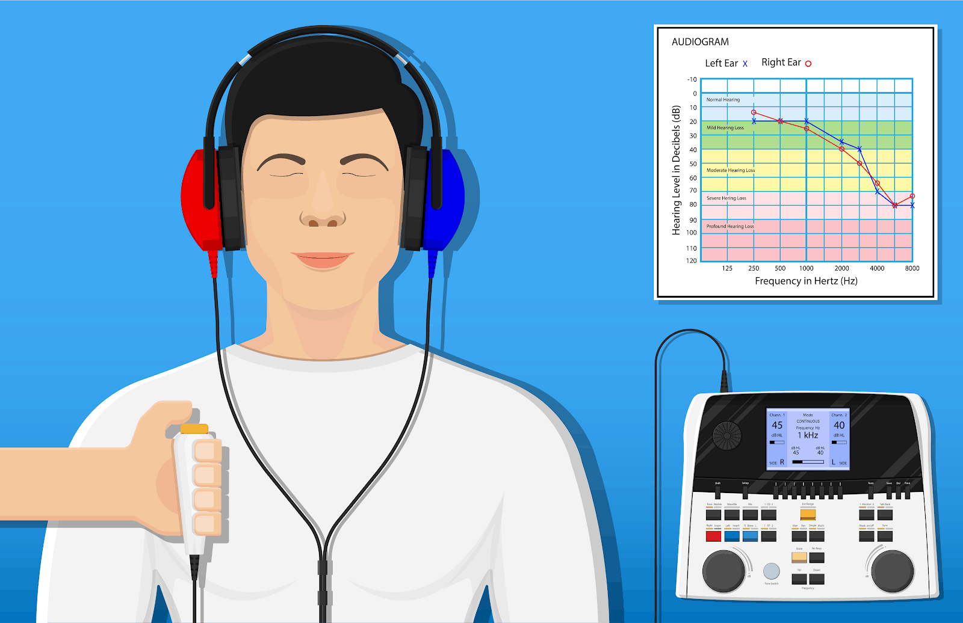

**Fig 4.1** Self-assessment audiometer

#### PORTABLE AUDIOMETER UTILIZING RASPBERRY PI

Central to the project is the development of a portable audiometer powered by Raspberry Pi technology. The Raspberry Pi serves as the core computing platform, offering a versatile and cost-effective solution for audiometric testing. Leveraging its computational capabilities, the audiometer can generate pure tones across various frequency ranges and deliver them to the patient via headphones. The portability of the device ensures flexibility in conducting assessments in diverse settings, from clinical environments to remote or home- based settings.

#### PORTABLE AUDIOMETER (RASPBERRY PI) VS MOBILE HEARING TEST

|  |  |  |
| --- | --- | --- |
| **FEATURES** | **PORTABLE AUDIOMETER (RASPBERRY PI)** | **MOBILE HEARING TEST** |
| **PICTURE** | Fig 4.3.1 PORTABLE AUDIOMETER | Fig 4.3.2. MOBILE HEARING TEST |
| **CALIBRATION LEVEL** | Utilizes precise calibration of sound pressure levels (SPL) | Varies widely, dependent on the quality and calibration of mobile devices |
| **TONE USED** | Pure tones of varying frequencies | Pure tones or speech signals depending on the app |
| **BENEFITS** | Provides accurate and reliable results, customizable, integrates with various software | Highly accessible, convenient, and easy to use |
| **CROSS-EAR LEVELS** | Allows for detailed measurement of interaural attenuation (cross-hearing) | Limited capability to assess cross-ear hearing accurately |
| **OPERATION** | Requires basic technical knowledge for setup and operation | User-friendly apps, minimal technical knowledge required |
| **PORTABILITY** | Highly portable, but requires several components (Raspberry Pi, headphones, etc.) | Extremely portable, just requires a smartphone and headphones |

|  |  |  |
| --- | --- | --- |
| **COST** | Moderate initial cost for hardware components | Low cost, often just the price of the app or free |
| **EASE OF USE** | Requires initial setup and familiarization | Intuitive interfaces, minimal setup required |
| **FLEXIBILITY** | High, can be customized for various audiometric tests | Moderate, depends on app features |
| **DATA STORAGE** | Saves results in CSV files, easy to manage and analyze | Saves results within the app or cloud storage, varies by app |
| **TECHNOLOGY** | Uses Raspberry Pi 3 B+, Python programming for automation | Utilizes smartphone technology and app-based interfaces |

**Table 2: Portable Audiometer (Raspberry Pi) Vs Mobile Hearing Test**

### Self-Assessment Audiometer For Testing: Possible And Not Possible Scenarios

##### Possible to Take Test:

* + - * **Routine Home Screening**: Individuals can perform routine checks at home.
      * **Convenient Monitoring**: Patients can monitor their hearing conveniently.
      * **Remote Accessibility**: Accessible in remote areas without audiologists.
      * **Cost-Effective Solution**: Affordable alternative to traditional tests.
      * **Follow-Up Testing**: Easily conduct follow-up tests at home

##### Not Possible to Take Test:

* + - * **Severe Hearing Impairments**: Profoundly deaf individuals may not respond accurately.
      * **Pediatric Testing**: Young children and infants may not understand the test.
      * **Complex Disorders**: Detailed diagnostic procedures are required for complex conditions.
      * **Calibration and Accuracy**: Potential calibration issues affecting accuracy.
      * **Technological Proficiency**: Difficulty for users lacking technological skills.
      * **Environmental Noise**: Testing in noisy environments can lead to inaccurate results.
      * **Professional Interpretation**: Some results may require professional interpretation.

#### EXISTING VS PROPOSED SELF-ASSESSMENT AUDIOMETERS

|  |  |  |
| --- | --- | --- |
| **FEATURE** | **PORTABLE SELF- ASSESSMENT AUDIOMETER** | **TRADITIONAL AUDIOMETER** |
| **PICTURE** | Fig 4.5.1 PORTABLE AUDIOMETER | Fig 4.5.2. AUDIOMETER |
| **CALIBRATION LEVEL** | Calibrated to a specific sound pressure level (SPL) | Requires professional calibration to maintain accuracy |
| **TONE USED** | Pure tones across various frequencies | Pure tones across various frequencies |
| **BENEFITS** | Cost-effective, convenient, and user- friendly | Highly accurate with professional oversight |

|  |  |  |
| --- | --- | --- |
| **CROSS-EAR LEVELS** | Managed by software algorithms to minimize cross-hearing | Audiologist adjusts to prevent cross- hearing |
| **OPERATION** | Automated testing procedure with patient-controlled responses | Audiologist conducts and adjusts the test manually |
| **PORTABILITY** | Highly portable; consists of Raspberry Pi, headphones, button | Generally stationary, housed in clinics or hospitals |
| **COST** | Lower cost due to use of affordable components and open-source software | Higher cost due to sophisticated equipment and professional fees |
| **ACCESSIBILITY** | Accessible at home or in remote locations | Accessible primarily in medical or audiology facilities |
| **EASE OF USE** | Designed for ease of use by individuals with minimal training | Requires an audiologist to operate |
| **FLEXIBILITY** | Flexible; can be used in various settings and by different users | Limited to clinical settings and use by trained personnel |
| **DATA STORAGE** | Results saved automatically as CSV files with date/time stamps | Data typically recorded manually or through clinic software |
| **TECHNOLOGY** | Uses Raspberry Pi 3 B+, Python for software implementation | Utilizes advanced audiometric equipment and specialized software |

**TABLE 3: EXISTING VS PROPOSED SELF-ASSESSMENT AUDIOMETERS**

## CHAPTER – 5

**PURE TONE AUDIOMETER**

#### INTRODUCTION

A pure tone audiometer serves as a specialized tool for evaluating an individual's auditory capabilities. It administers pure tones of varying frequencies and strengths to each ear independently, enabling audiologists to ascertain the faintest sounds detectable by the person across different frequencies. This data is then utilized to generate an audiogram, a visual representation illustrating the individual's hearing thresholds across various frequencies.

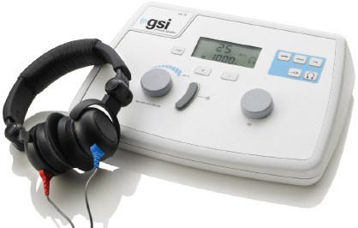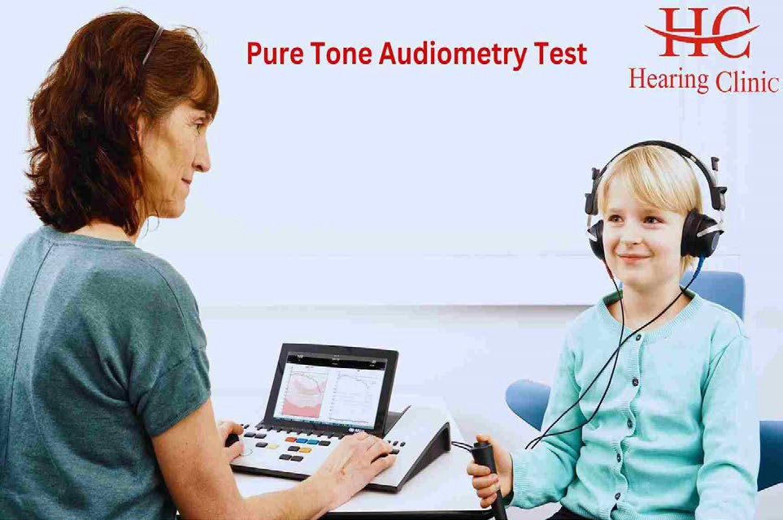

Fig 5.1. **Pure tone audiometer**

#### PURPOSE OF PURE TONE AUDIOMETER

* + 1. Assess hearing abilities accurately.
    2. Diagnose various types and degrees of hearing loss.
    3. Plan appropriate treatments, such as hearing aids or surgery.
    4. Monitor changes in hearing sensitivity over time.
    5. Screen for occupational and clinical hearing health.
    6. Contribute to research and education in audiology.

#### TYPES OF TESTING

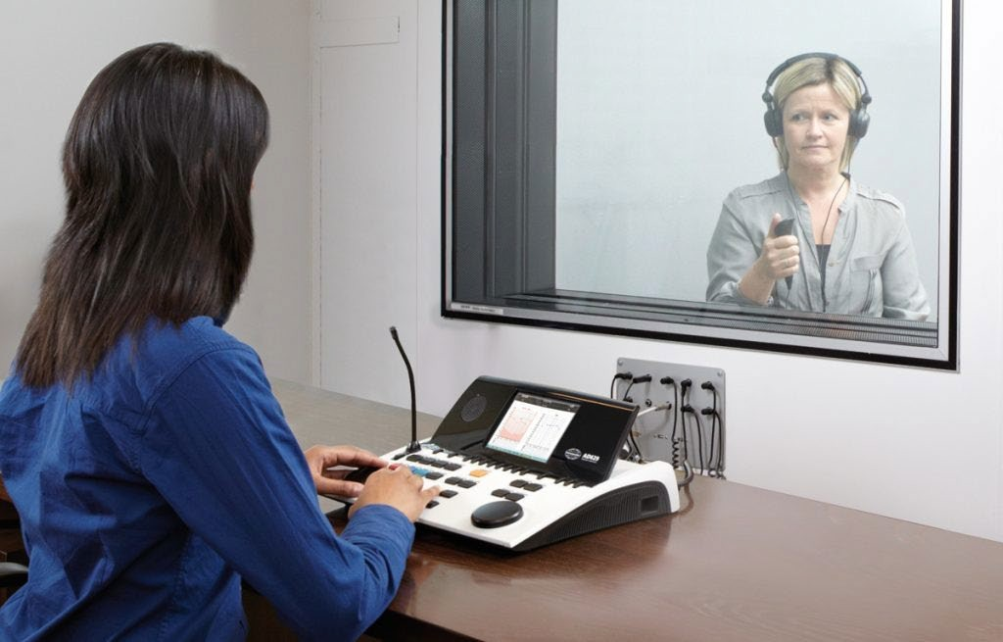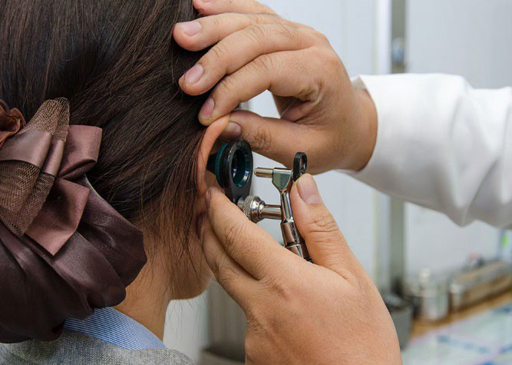

Fig 5.3. Types of testing

Pure tone audiometry comprises various testing modalities to evaluate different aspects of hearing. Here are the primary types:

##### Air Conduction Test:

This form of pure tone audiometry, widely used, entails delivering pure tones via headphones or speakers to determine the lowest audible sounds across a spectrum of frequencies. It examines the entire auditory pathway, from the external ear to the brain's processing of auditory stimuli.

##### Bone Conduction Test :

This testing method involves placing a bone vibrator behind the ear to directly stimulate the inner ear, bypassing the outer and middle ear. It helps discern whether hearing loss stems from issues in the outer or middle ear (conductive hearing loss) or the inner ear or auditory nerve (sensorineural hearing loss).

##### Speech Audiometry:

This evaluation gauges an individual's capacity to perceive and comprehend speech. It determines the minimum sound intensity at which an individual can recognize and repeat words, offering insights into speech perception and discrimination abilities.

##### Masking:

Masking is employed when one ear might inadvertently perceive sounds intended for the other ear, particularly in cases of significant hearing asymmetry. It entails presenting noise to the non-test ear to ensure that only the test ear responds to the pure tones.

##### Specialized Testing for Pediatric Population

Pediatric audiometry may incorporate interactive behavioral testing methods, such as visual reinforcement audiometry (VRA) or conditioned play audiometry (CPA), which are more engaging for young children and yield reliable hearing thresholds.

##### Tympanometry:

Although not a pure tone test per se, tympanometry is often conducted alongside pure tone audiometry. It evaluates the mobility of the eardrum and the functionality of the middle ear, aiding in the diagnosis of conditions like otitis media or eustachian tube dysfunction.

#### AUDIOGRAM

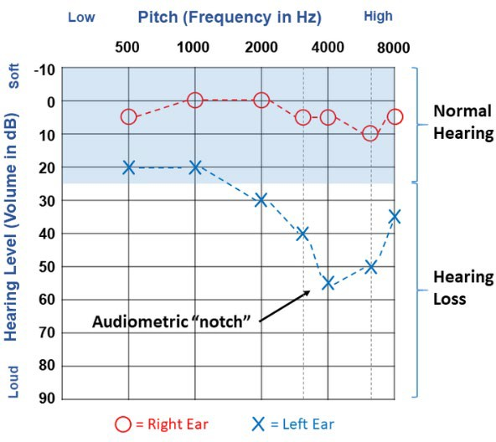

Fig 5.4. Audiogram

An audiogram serves as a visual representation depicting an individual's hearing capacity across different frequencies and levels of intensity. It holds significant importance in audiology for evaluating and diagnosing hearing impairments. Typically, the graph illustrates frequencies ranging from low to high along the horizontal axis (x-axis), measured in Hertz (Hz), and sound intensity or volume along the vertical axis (y-axis), measured in decibels (dB).

The results of audiograms are derived from a series of tests wherein the individual responds to various tones or sounds. The audiologist documents the faintest sound audible to the person at each frequency, forming a profile of hearing thresholds. Offering insights into the type, severity, and pattern of hearing loss, the audiogram assists audiologists in devising appropriate interventions, such as recommending hearing aids or other necessary measures.

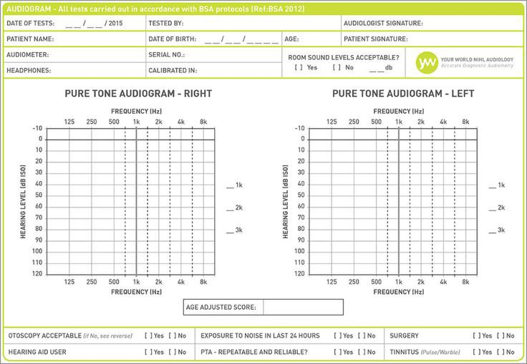

Fig 5.4.1. Audiogram Sheet

#### AUDIOGRAM CONFIGURATION

The structure of an audiogram chart illustrates an individual's hearing thresholds across various frequencies. Typical patterns encompass uniform (flat) loss, gradual (sloping) decline with higher frequencies predominantly affected, increasing (rising) loss with lower frequencies predominantly impacted, mid-frequency emphasis (U-shaped), and severe loss across all frequencies (corner).

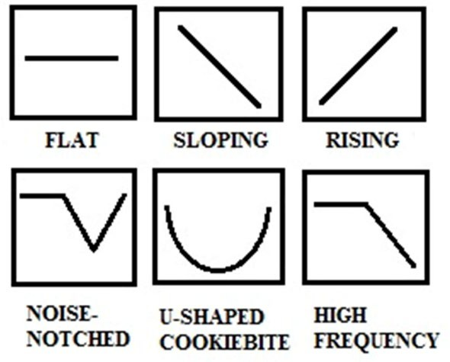

Fig 5.5. Audiogram Configuration

#### LIMITATIONS

* + 1. **Speech Understanding**: Audiograms don't measure how well someone understands speech, which can be affected by factors beyond hearing sensitivity.
    2. **Sound Quality**: They don't capture sound quality or distortion, which can impact speech comprehension even if sounds are detected.
    3. **Frequency Range**: Audiograms may not detect very low or very high-frequency losses, which can affect perception in specific situations.
    4. **Localization**: They don't assess the ability to locate sounds, important for spatial awareness and safety.

#### APPLICATION

Pure tone audiometers are essential tools for:

* + 1. **Hearing Assessment**: They accurately assess hearing sensitivity, aiding in diagnosis and classification of hearing loss.
    2. **Treatment Monitoring**: Audiometers help monitor treatment effectiveness, such as hearing aid usage.
    3. **Screening**: They're used for occupational and clinical hearing screenings.
    4. **Research and Education**: Audiometers support research and education in audiology.

#### FEATURES

* + 1. **Wide Frequency Range**: Covering low to high frequencies.
    2. **Intensity Control**: Allows precise sound level adjustment.
    3. **Ear Configurations**: Accommodates various testing methods, including air and bone conduction.
    4. **Masking Capabilities**: Ensures accurate results, especially for asymmetric hearing loss.
    5. **Data Management**: Offers storage and connectivity options for patient records.
    6. **Portability**: Some models are portable for testing flexibility.

## CHAPTER - 6 IMPLEMENTATION OF HARDWARE MODULES

#### INTRODUCTION

The portable pure tone audiometer utilizes a Raspberry Pi 3 B+, alongside a mouse and headphones. The Raspberry Pi operates on the Raspbian OS and is equipped with a 64-bit

1.2GHz quad-core processor and essential connectivity ports. Programmed in Python, it facilitates straightforward script development. Leveraging the Raspberry Pi's ALSA sound card, the audiometer produces pure tones spanning frequencies from 125 Hz to 8 kHz.

These tones are conveyed through a 3.5mm audio jack to HP102BK headphones worn by the patient. Testing initiates automatically with the right ear and is masked to prevent erroneous responses. The patient indicates tone perception by pressing the mouse button, prompting frequency and intensity adjustments through Python scripting.

#### 6.2. BLOCK DIAGRAM

This initiative empowers individuals experiencing hearing challenges to self-assess their auditory abilities and ascertain the extent of their hearing range. The schematic representation of the envisaged portable audiometer is illustrated in Figure 6.2.

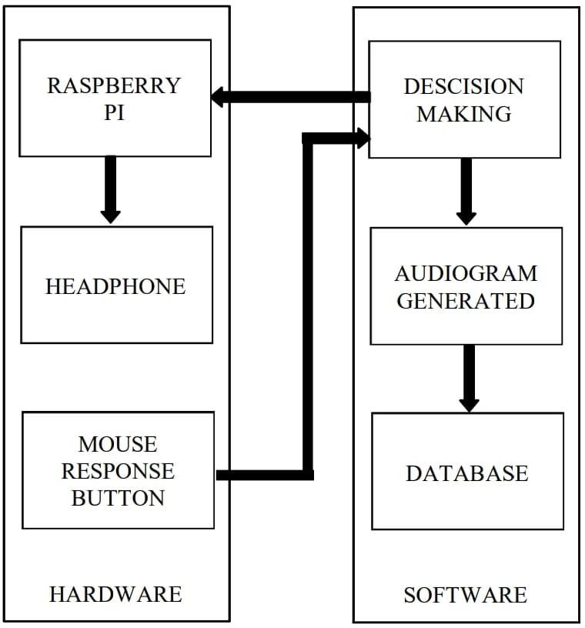

Fig 6.2. Block Diagram

#### COMPONENT DESCRIPTION

* + 1. **RASPBERRY PI**

The Raspberry Pi, a line of compact single-board computers (SBCs), was developed by the Raspberry Pi Foundation in partnership with Broadcom in the United Kingdom. Initially designed to enrich fundamental computer science education in educational institutions, Raspberry Pi quickly expanded beyond its educational role, attracting a broad spectrum of users from enthusiasts to industrial pioneers.

Its cost-effectiveness, along with its modular structure and inclusion of standard interfaces like HDMI and USB, elevated Raspberry Pi into a flexible platform suitable for various uses, such as multimedia centers, robotics, and home automation setups

The establishment of Raspberry Pi (Trading) Ltd, led by visionary Eben Upton, marked a pivotal moment in the evolution of the Raspberry Pi ecosystem. While maintaining its commitment to education, the Foundation pivoted towards commercial endeavors, ensuring the widespread availability of Raspberry Pi devices through manufacturing facilities in Wales, China, and Japan.

Surpassing the iconic ZX Spectrum in 2015, Raspberry Pi emerged as the best-selling British computer, solidifying its status as a beacon of innovation and accessibility in the computing realm. In 2021, the rebranding of Raspberry Pi (Trading) Ltd to Raspberry Pi Ltd reaffirmed its enduring mission to foster innovation and empower learners worldwide.

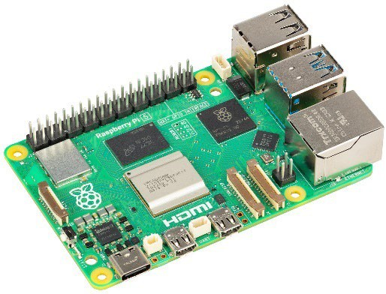

**Fig 6.3.1** Raspberry Pi

#### FEATURES OF RASPBERRY PI:

The general features of this board are as follows:

* + - * 1. **Affordability**: Raspberry Pi offers a low-cost computing solution.
        2. **Versatility**: It suits a wide range of projects, from simple electronics to complex IoT applications.
        3. **GPIO Pins**: GPIO pins enable interaction with external components.
        4. **Community Support**: A large and active community provides ample resources and assistance.
        5. **Education**: Raspberry Pi promotes learning programming and electronics, originally designed for educational purposes.

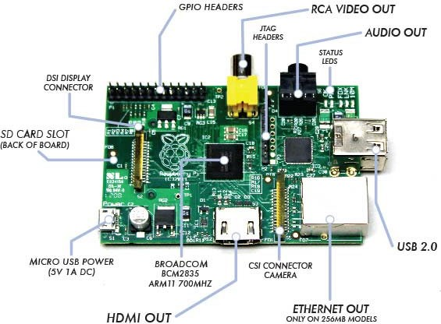

**Fig 6.3.2** Pin Description of Raspberry Pi

* + - 1. **RASPBERRY PI GPIO’S PIN**
* GPIO (General Purpose Input/Output) pins enable interaction with external components. They act as programmable switches for controlling (output) or reading from (input) devices.
* These pins are grouped into sets for specific purposes like power, ground, digital I/O, and analog input.
* Raspberry Pi models offer varying numbers and configurations of GPIO pins, typically in a row of 40 (some models feature 26).
* GPIO pins facilitate a wide range of projects by allowing users to interface with sensors, LEDs, motors, and other peripherals.

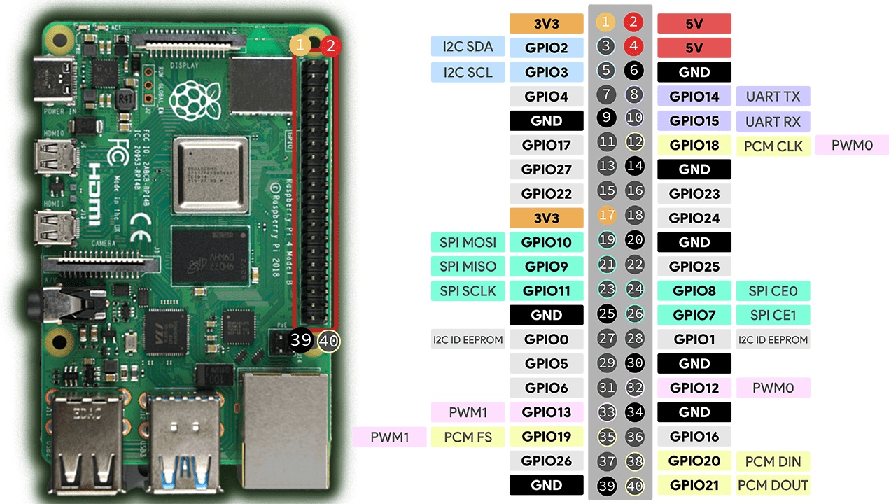

**Fig 6.3.3 Raspberry Pi GPIO’s Pin Layout**

#### RASPBERRPY PI PIN DETAILS

* + - * 1. **Power Pins**: Supply power to external devices (5V and 3.3V).
        2. **Ground Pins**: Provide reference voltage for circuits.
        3. **Digital I/O Pins**: Read inputs or control outputs.
        4. **Analog Input Pins**: Read analog signals from sensors.
        5. **Special Function Pins**: Handle specific communication protocols like I2C, SPI, UART, or PWM.

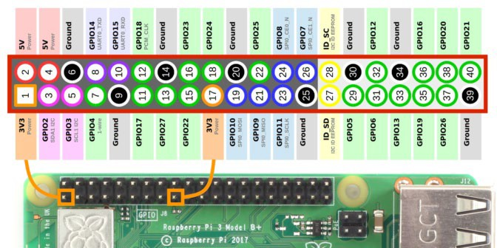

Fig 6.3.4 Raspberry Pi GPIO

#### RASPBERRY PI CASE:

A protective enclosure designed to house and shield the Raspberry Pi 3 B+ from physical damage and environmental hazards.

##### Features:

* 1. Secure enclosure to safeguard the Raspberry Pi components.
  2. Accessible openings for ports, GPIO pins, and camera/display connectors.

##### Specifications:

* Material: Plastic or aluminum
* Design: Ventilation holes for heat dissipation, mounting holes for stability.

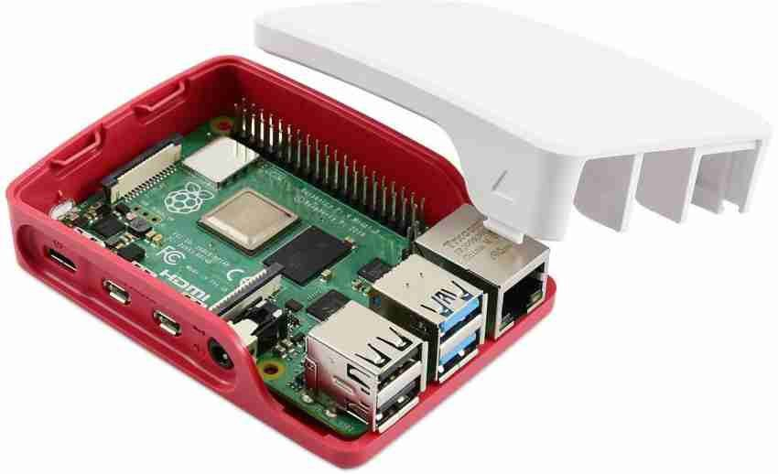

Fig 6.4. Raspberry Pi Case

#### MOUSE

The mouse is an input device used for interacting with graphical user interfaces on computers.

##### Features:

* 1. Ergonomic design for comfortable use.
  2. Responsive optical or laser sensor for precise cursor movement.

##### Specifications:

* Connectivity: Wired or wireless (USB or Bluetooth)
* Buttons: Left, right, scroll wheel

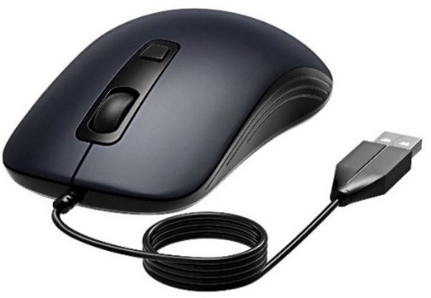

Fig 6.5 Mouse

#### HEADPHONE:

The headphone delivers audio output to the user for listening to sound from the Raspberry Pi.

##### Features:

* 1. High-quality audio reproduction for immersive sound experience.
  2. Comfortable design for extended wear.

##### Specifications:

* Type: Over-ear or in-ear
* Connectivity: Wired (3.5mm audio jack) or wireless (Bluetooth)
* Frequency Response: Typically ranges from 20Hz to 20kHz

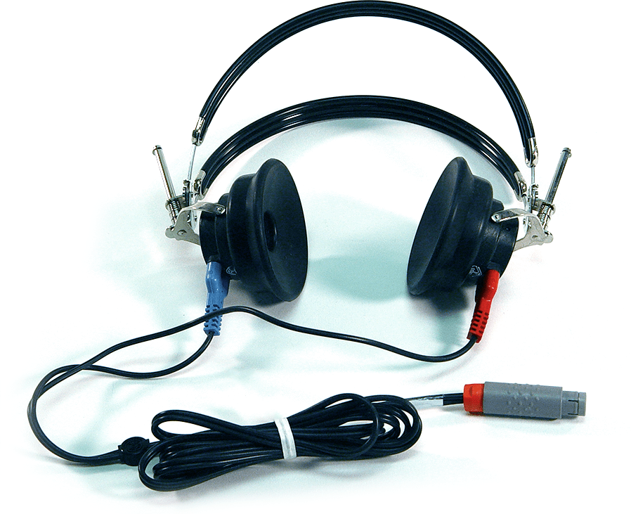

Fig 6.6. Headphoney

#### TDH 49 HEADPHONE CHARACTERISTICS AND USAGE:

##### Tone Used:

* + Pure tones across various frequencies for audiometric testing.

##### Positive Characteristics:

* + Reliable and consistent in delivering precise sound stimuli.
  + Closed design attenuates ambient noise for accurate testing.

##### Negative Characteristics:

* + Bulky size and weight may cause discomfort during prolonged use.
  + Closed design can lead to heat and moisture buildup, causing discomfort.

##### Cross Ear Level:

* + Designed to minimize cross-hearing with good acoustic isolation.
  + Proper positioning crucial for minimal sound leakage and accurate results.

##### Crossover:

* + Potential feature for consistent sound quality across frequencies.
  + Ensures accurate and reliable audiometric testing results.

#### ETHERNET CABLE:

The Ethernet cable establishes a wired network connection between devices for high-speed data transfer.

##### Features:

* + Secure and stable network connectivity.
  + Twisted pair construction for reduced interference.

##### Specifications:

* Cable Category: Cat5e, Cat6, Cat6a
* Length: Various lengths available
* Speed: Typically up to 1Gbps

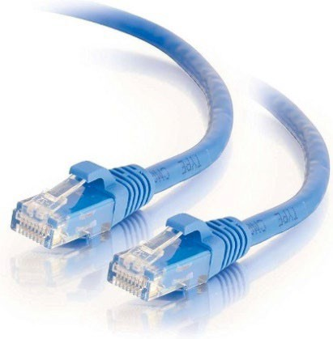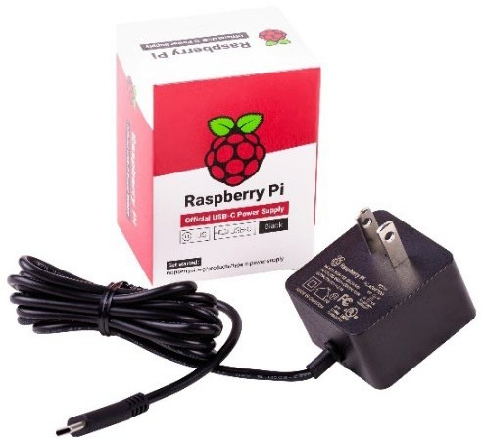

Fig 6.7. Ethernet Cable: Fig 6.8 Power Adapter

##### Power Supply

The power source delivers essential electrical energy to the Raspberry Pi and accompanying components of the audiometer, ensuring steady and dependable functionality of the system.

##### Characteristics:

* + Provides consistent output voltage for reliable performance.
  + Equipped with safety measures like overload and short-circuit protection.

##### Specifications:

* + Input: AC 100-240V, 50/60Hz
  + Output: DC 5V, 2.5A
  + Connector Type: Micro USB

## CHAPTER – 7 SOFTWARE IMPLEMENTATION

#### 7.1 INTRODUCTION

In Technology, the word implementation of software is used to describe the software tools implemented in this project.

#### 7.2. RASPBERRY PI OS (RASPBIAN)

Installing Raspberry Pi OS involves preparing a microSD card and setting up your Raspberry Pi. Here's a quick overview

* Installing Raspberry Pi OS via Raspberry Pi Imager offers a swift and straightforward method to set up the operating system on a microSD card, making it compatible with your Raspberry Pi for immediate use.

[**https://downloads.raspberrypi.org/imager/imager_latest.exe**](https://downloads.raspberrypi.org/imager/imager_latest.exe)

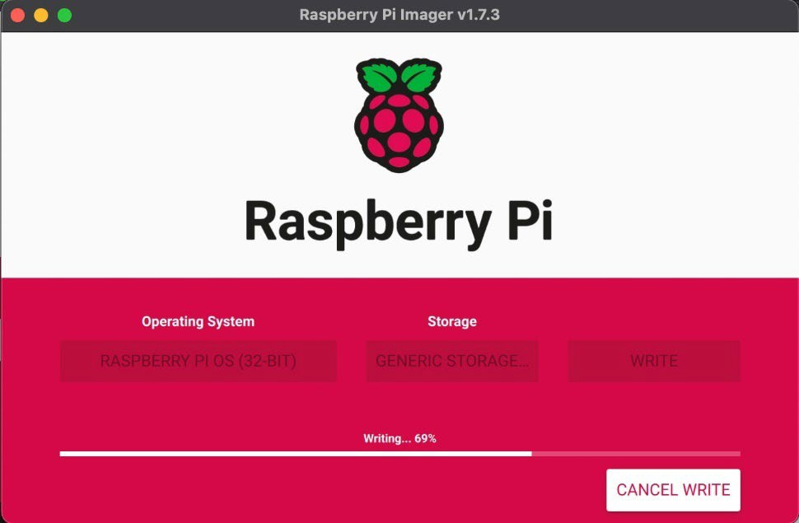

Fig 7.2 Installing Raspbian.

1. **Download Raspberry Pi Imager:** This tool writes the OS to your SD card. Get it from the Raspberry Pi website.
2. **Prepare microSD card:** Use a minimum 8GB class 10 card. The imager will erase it during setup.
3. **Flash OS to SD card:** Use the imager to select Raspberry Pi OS (formerly Raspbian) and your SD card. The imager will write the OS to the card.
4. **Setup Raspberry Pi:** Insert the SD card, connect a monitor, keyboard, mouse, and power supply to your Pi. You can also connect to Wi-Fi during initial setup.

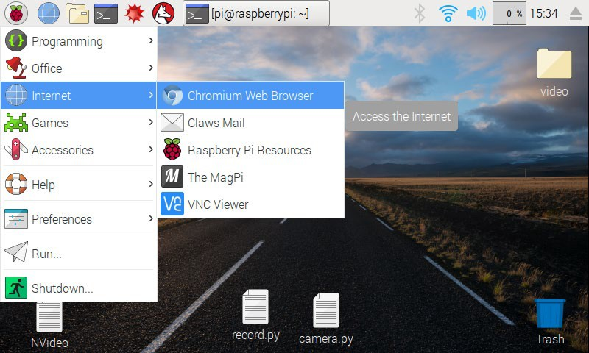

Fig 7.2.1 The Raspberry Pi desktop.

##### 6.3. VNC: Remote access a Raspberry Pi

To install VNC Viewer on your computer and connect to your Raspberry Pi:

1. **Download VNC Viewer**: Visit the RealVNC website and download the VNC Viewer application for your operating system.
2. **Install VNC Viewer**: Follow the on-screen instructions to install VNC Viewer on your computer.
3. **Configure Raspberry Pi**: On your Raspberry Pi, enable VNC Server. You can do this by opening a terminal and running **sudo raspi-config**, navigating to **Interfacing Options**, and enabling VNC.
4. **Find Raspberry Pi IP Address**: Use **ifconfig** on the Raspberry Pi terminal to find its IP address.
5. **Connect with VNC Viewer**: Open VNC Viewer on your computer and enter the Raspberry Pi's IP address. Click connect and enter the username and password for your Raspberry Pi when prompted.
6. **Access Raspberry Pi Desktop**: You should now be connected to your Raspberry Pi's desktop environment using VNC Viewer.

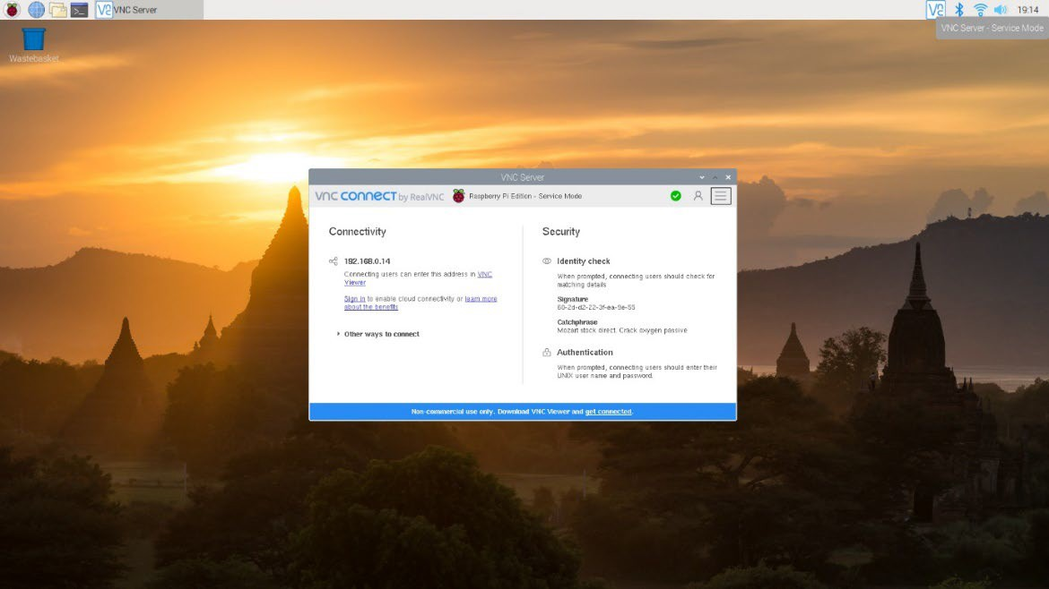

Fig 7.3 VNC: Remote Access to a Raspberry Pi

**7.4. Python on Raspberry Pi: Thonny Editor**

The Raspberry Pi OS includes a basic Python editor called "Thonny", providing a straightforward environment for writing and executing Python code directly on the Raspberry Pi.

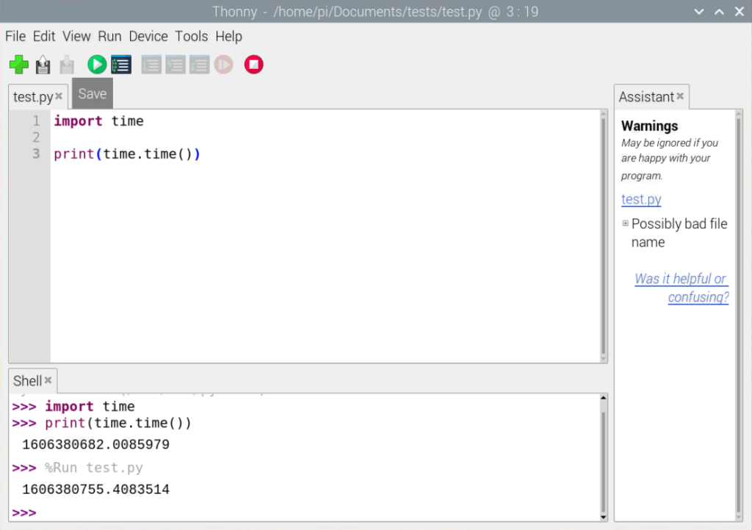

Fig 7.4 Thonny ide

## CHAPTER – 8

**VALIDATION AND FEEDBACK: MEETING WITH ENT DOCTOR**

**Consultation with Dr. B. Harsha Vardhan, M.S. ENT (Otolaryngology)**

## INTRODUCTION

To develop a portable audiometer for self-assessment of hearing loss, we sought input from Dr. B. Harsha Vardhan, an ENT expert, to gather practical insights and evaluate the device's effectiveness. Dr. Vardhan provided valuable guidance and feedback on the project.

## CONSULTATION WITH DR. B. HARSHA VARDHAN, M.S. ENT (OTOLARYNGOLOGY)

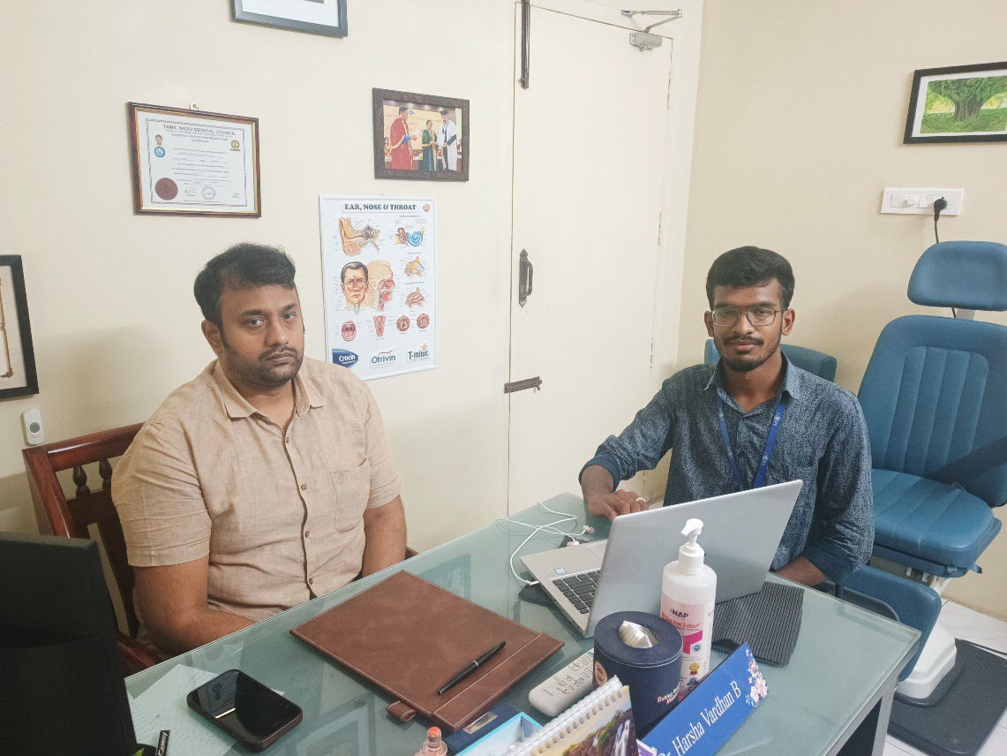

**Fig 8.2. Consulting with the Doctor**

* + - We met Dr. B. Harsha Vardhan, an ENT specialist based in Mahalingapuram, Pollachi.
    - During the meeting, we discussed the project and demonstrated the functionality of the pure tone audiometer.
    - Dr. Vardhan praised the project, considering it highly promising.
    - He expressed interest in purchasing the pure tone audiometer once it is completed.
  1. **Recommendation to Meet an Audiologist:**
     + Dr. Vardhan recommended meeting with an audiologist in Pollachi for further validation of the device.
     + He provided contact details of an audiologist in Pollachi for additional consultation.
  2. **Discussion with the ENT Doctor:**
     + We spoke with the audiologist and discussed the project in detail.
     + We learned that the market value of a commercial pure tone audiometer is approximately 1.50 lakhs.
     + The audiologist advised us to test the self-assembled pure tone audiometer with individuals who are hearing impaired for further validation.
     + Feedback was given on making minor adjustments to the audiogram's x and y-axis for improved accuracy.
  3. **Testing the Self-Assembled Pure Tone Audiometer:**
     + We met with an audiologist in Pollachi who had access to a commercial pure tone audiometer.
     + Comparative tests were conducted between the self-assembled audiometer and the commercial device.
     + The results indicated that the self-assembled device performed well, with only slight variations in audio tones
  4. **Feedback and Conclusion:**
     + Dr. Vardhan appreciated the innovative project and participated in testing the audiometer.
     + The project received positive feedback overall, with suggestions for minor adjustments to enhance accuracy.
     + Collaboration with medical professionals validated the effectiveness of the self- assembled pure tone audiometer, reinforcing its potential utility.

## CHAPTER - 9

**MEETING WITH AUDIOLOGIST BALACHANDRAN, ASLP**

**Consultation with Dr. P. Balachandran, ASLP**

#### INTRODUCTION:

During a recent visit to Pollachi, I had the opportunity to meet with Audiologist Balachandran, ASLP. We engaged in an in-depth discussion about audiometric equipment and testing procedures for over an hour.

#### MEETING WITH AUDIOLOGIST BALACHANDRAN ASLP IN POLLACHI

In Pollachi, I met with Audiologist Balachandran, ASLP, for an enlightening conversation lasting over an hour. He introduced me to essential audiology testing equipment, including the Auditivio Audiometer (Endeavour), an Indian product priced at ₹50,000, and the imported Flute Inventis Tympanometer, which costs ₹4.50 lakhs

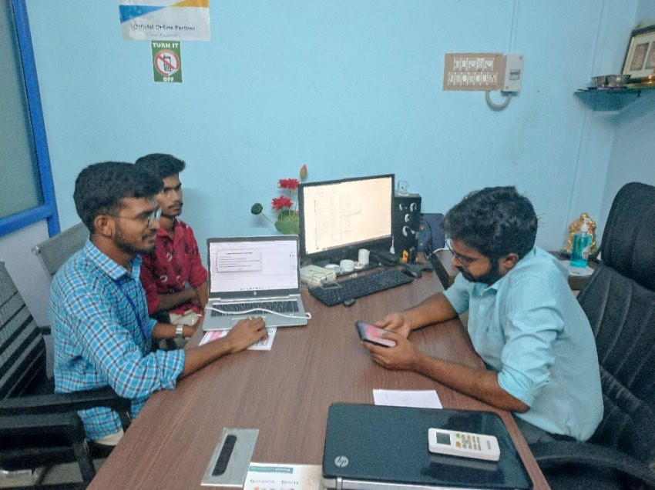

Fig 9.2. Meeting with Audiologist

#### PROJECT DISCUSSION AND RECOMMENDATIONS

Balachandran provided valuable insights and suggestions for enhancing our project. He emphasized the importance of including a bone conduction test to accurately plot the audiogram and describe hearing loss. He also recommended replacing the standard headphones with TDH49, which are specifically designed for audiometry tests. Furthermore, he suggested printing the audiogram sheet for proper documentation**.**

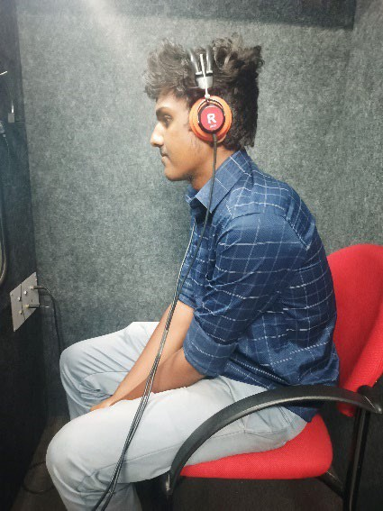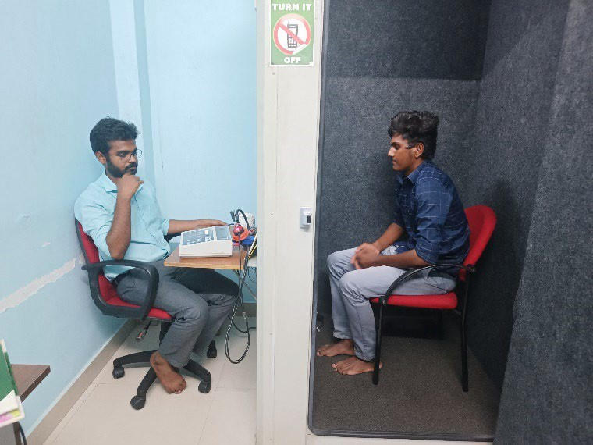

Fig 9.3. Audiometry Test

#### QUESTIONS AND AUDIOMETER INSIGHTS

During our conversation, Balachandran posed several insightful questions regarding audiometry:

* + - He inquired about the differences between our project and a pure tone audiometer.
    - He discussed the disparity between a hearing test app and a self-assessment audiometry test.
    - He questioned the significance of intensity changes in our project.
    - He suggested studying the characteristics of the TDH49 headphones, including their crossover and ear levels.
    - He prompted us to explore calibration levels for sound pressure levels in our self- assessment portable audiometer.
    - He compared the cost-effectiveness of our project with a pure tone audiometer.
    - He raised queries about the intensity and time delay in our project.
    - He advised researching the maximum frequency intensity of an audiometer.

#### GUIDANCE AND LEARNING

Balachandran recommended the book "Auditory Diagnosis" by Robert and requested a hard copy of our project documentation. We provided him with detailed study material. He also explained the Mackenzie audiometry test, highlighting its significance.

#### KEY FEEDBACK FROM AUDIOLOGIST BALACHANDRAN

* + - **Bone Conduction Tests:** Essential for accurate audiogram plotting and describing hearing loss.
    - **TDH49 Headphones:** Recommended replacing standard headphones with TDH49 for audiometry tests.
    - **Printed Audiogram Sheets**: Necessary for proper documentation.
    - **Calibration Levels:** Explore and implement sound pressure level calibration for accuracy.
    - **Intensity and Time Delay Adjustments:** Needed for better test accuracy.
    - **Maximum Frequency Intensity**: Research the maximum frequency intensity levels.
    - **TDH49 Headphone Characteristics:** Study crossover and ear level responses.
    - **Cost-Effectiveness:** Compare the project’s cost-effectiveness with pure tone audiometers.
    - **Mackenzie Audiometry Test**: Consider incorporating or adapting principles from this test
    - **High-Frequency Audiometry Tests:** Extend capabilities to include high-frequency audiometry tests.
    - **Detailed Documentation and User Manual:** Develop comprehensive documentation and a user manual.
    - **Enhanced User Interface**: Improve user interface for better usability.
    - **Real-Time Data Analysis and Feedback:** Integrate real-time data analysis and feedback features for immediate results.

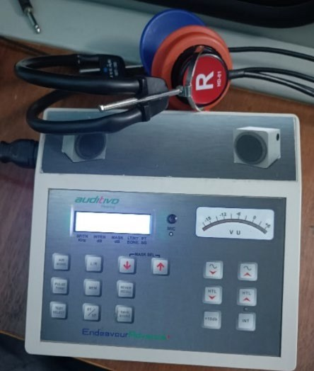

**Fig 9.6. Auditivo Audiometer**

#### EXPLORATION AND FUTURE SCOPE

Balachandran educated us on high-frequency audiometry tests and provided guidance for further development of our project. He offered detailed insights into masking tests, cross- level intensity, and various types of audiometry, and explained the concept of hearing loss.

#### CONCLUSION

The meeting with Balachandran was incredibly enlightening. We gained valuable insights into potential improvements and future prospects for our project. His expertise in audiometry testing and his recommendations were instrumental in enhancing our understanding and guiding our project's direction.

## CHAPTER – 10 RESULTS

#### 10.1 INTRODUCTION

This chapter explains the testing of the working of hardware, software, raspberry pi (Pure Tone Audiometry) of the project.

#### 10.2. TESTING OF FINAL WORKING MODEL:

The integration of the audiogram for assessing hearing loss was effectively achieved within the Python framework, aided by a computer, a Raspberry Pi, and headphones. Utilizing the sound card of the Raspberry Pi 3 B+, pure tones of different frequencies and strengths were produced. These tones were subsequently delivered to the headphones worn by the hearing- impaired individual. The individual's reactions, triggered by clicking the left mouse button, were captured and logged by the Python program through the Raspberry Pi configuration.

Before commencing the audiometric test, individuals with hearing impairment were provided with essential software instructions:

##### Functional Verification:

The portable audiometer effectively conducted pure tone audiometry tests, generating automatic audiograms based on patient responses.

##### Data Storage and Analysis:

Test results were stored in CSV files, enabling detailed analysis of patient responses and comparison with traditional audiometry results.

##### Visualizations:

Audiogram charts provided visual representations of hearing levels across different frequencies, aiding interpretation of test results for both patients and healthcare professionals.

##### Accuracy and Reliability:

Validation testing demonstrated the audiometer's accuracy and reliability, with results comparable to those obtained from conventional audiometers.

##### Feedback Incorporation:

Feedback from medical professionals informed refinements to the audiometer's performance, enhancing its usability and effectiveness in clinical settings.

## 10.3 WORKING MODEL

##### Components:

Raspberry Pi 3 B+, computer, patient response button, and headphones.

##### Sound Signal Delivery:

Headphones deliver sound signals of varying frequencies and volumes.

##### Patient Response:

Patients respond using a mouse button, providing feedback for recording.

##### Data Processing:

Real-time processing captures frequency, volume, and reaction time data.

##### Output:

Generates audiograms and visualizations for easy interpretation of hearing levels.

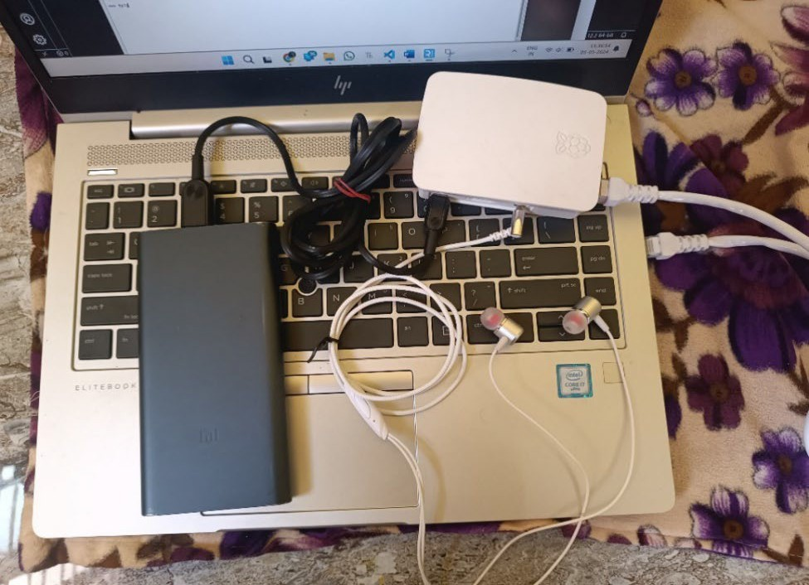

**Fig 10.3 Overall Initialization Pure Tone Audiometer**

## 10.4. RESULT ANALYSIS:

Using the data stored in the CSV file, the audiogram was produced to illustrate the hearing thresholds for both the right and left ears. The graph displayed the frequency, measured in Hertz, along the X-axis, and the sound intensity, measured in decibels (dB), along the Y-axis.

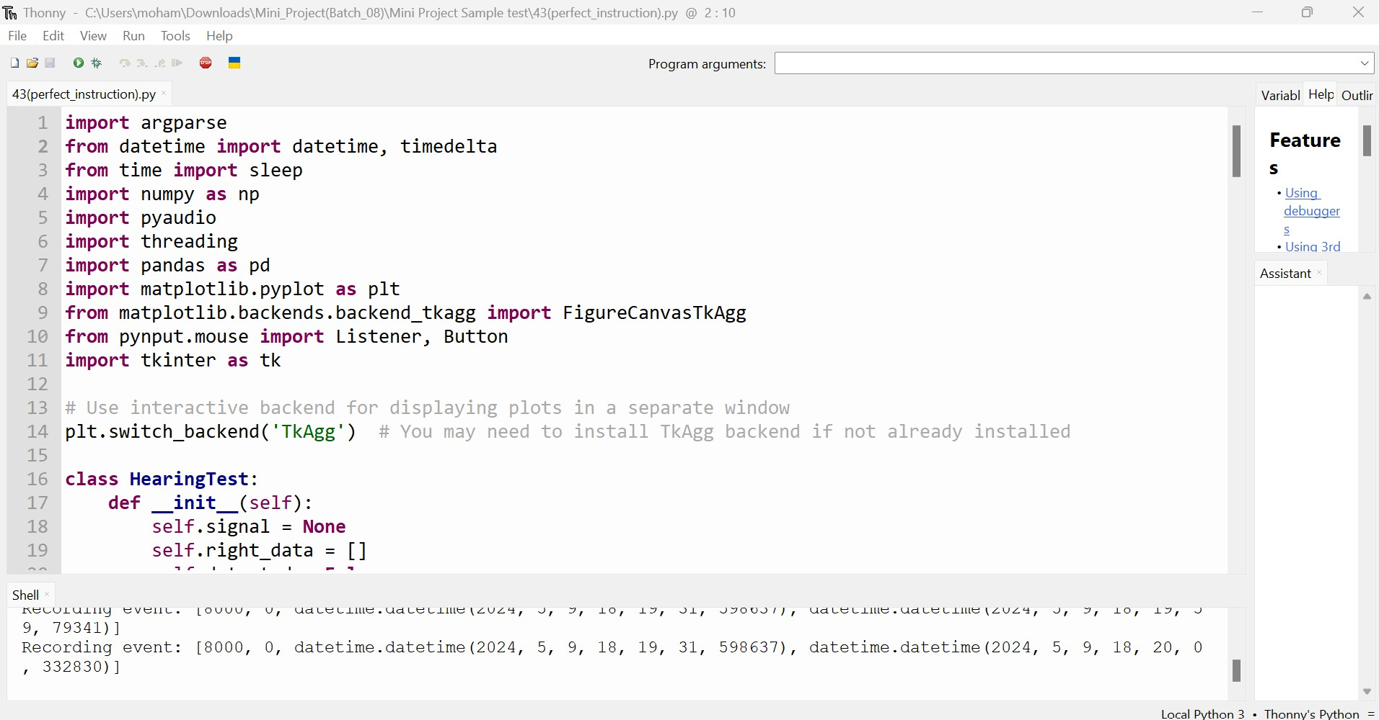

**Fig 10.4.1. Python Code in Thonny Ide**

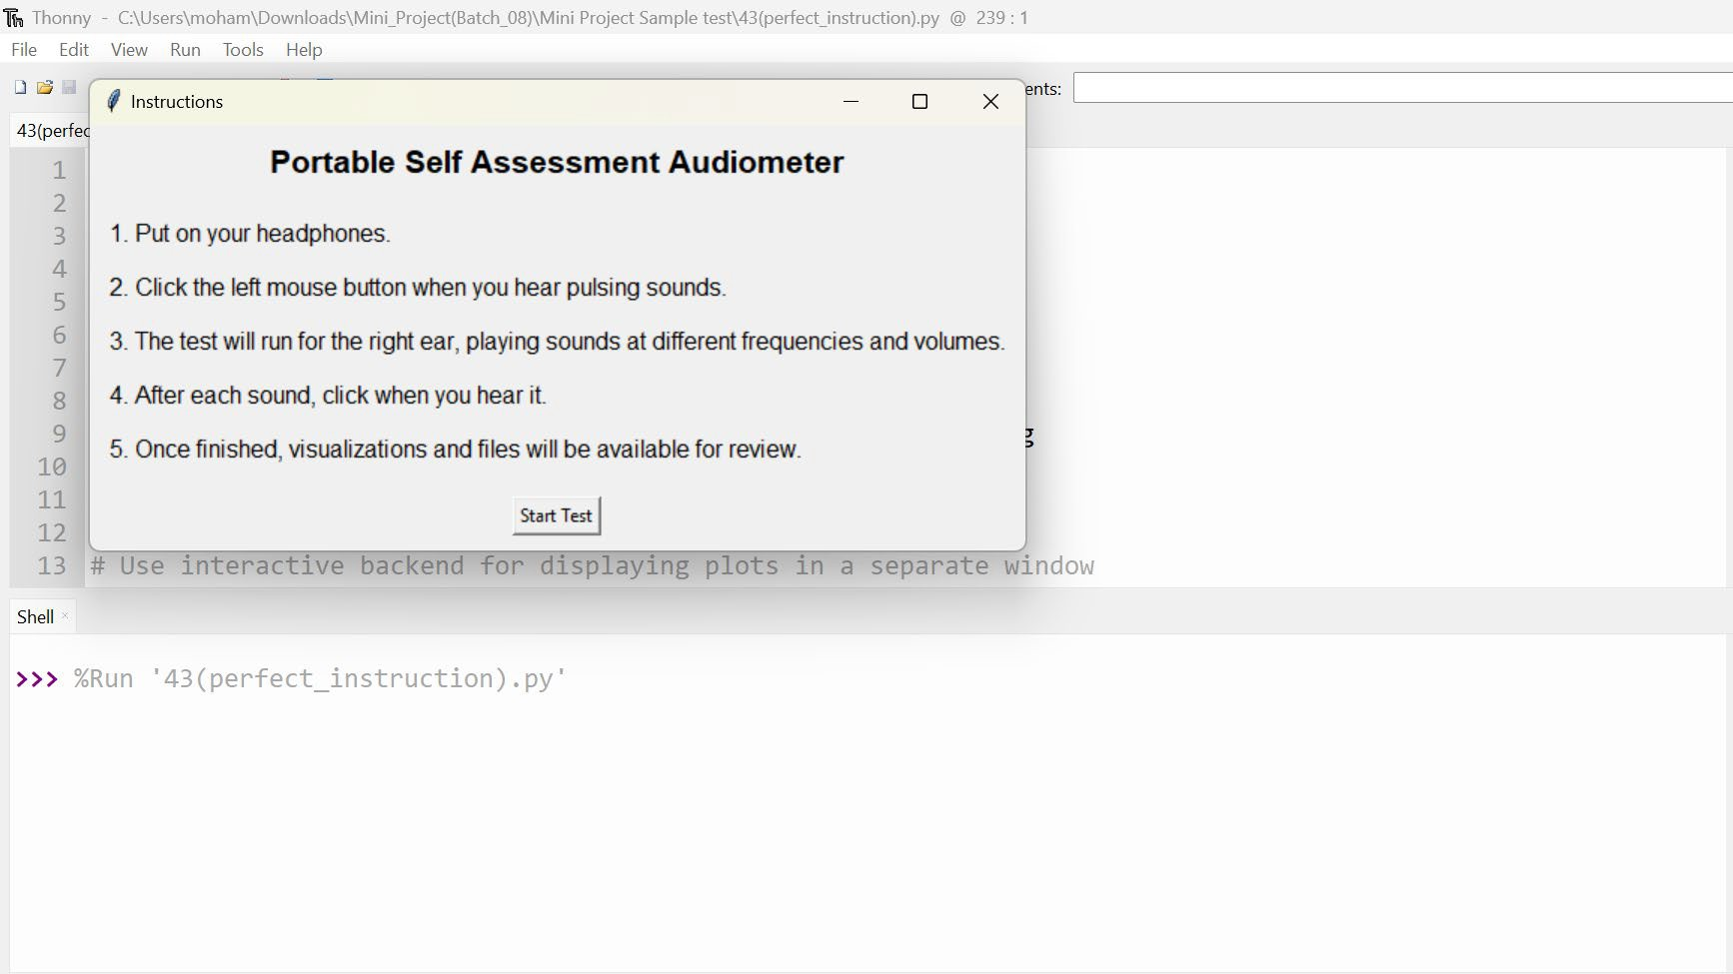

**Fig 10.4.2. Instruction of the project**

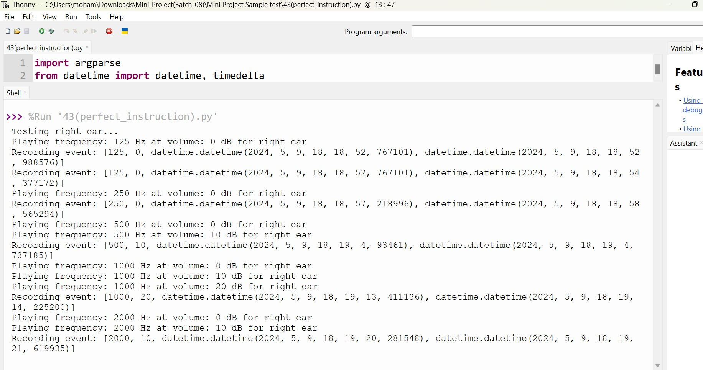

**Fig 10.4.3. Patient Response of the Audiometer**

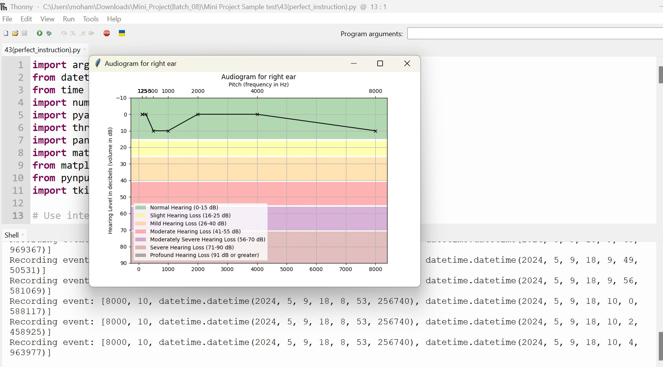

**Fig 10.4.4. Output of the Audiogram Chart**

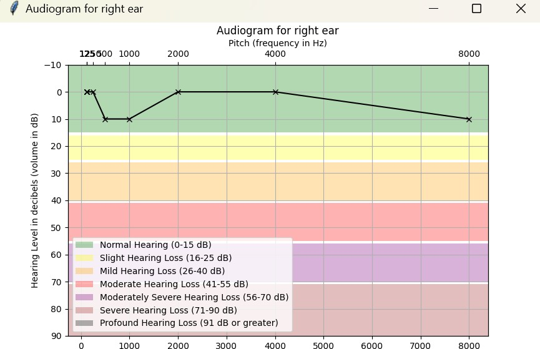

**Fig 10.4.5. Result Audiogram chart**

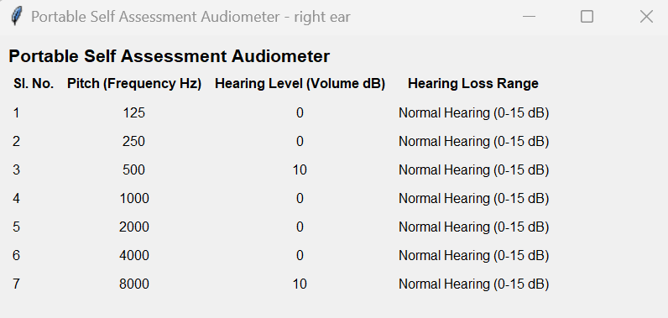

**Table 3: Result Analysis**

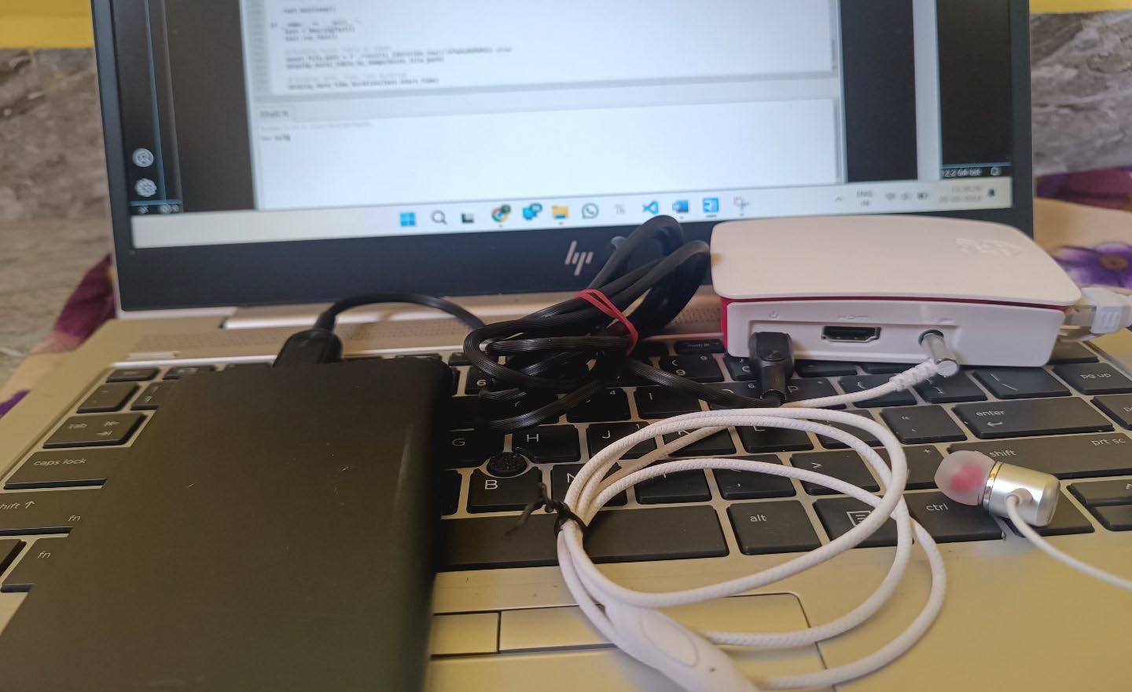

**Fig 10.4.6. Portable Self Assessment Audiometer**

## CHAPTER – 11 CONCLUSION

The project has resulted in a significant achievement: the development of a portable audiometer capable of autonomously and repeatedly diagnosing hearing loss. What distinguishes this portable device is its innovative incorporation of information technology into audiology equipment.

By utilizing the widely-adopted Python programming language, the system is accessible even to individuals without specialized expertise, and Python's user-friendly nature facilitates smooth integration with other devices.

The implementation of automated screening procedures in Python not only cuts down on operational expenses but also enhances the portability of the hearing screening tool. Furthermore, the created audiometer functions as a self-assessment system for hearing, eliminating the requirement for expert operation.

Looking forward, future advancements could focus on integrating Active Noise Cancelling technology into the headphones. This upgrade would effectively reduce ambient noise levels, creating a more conducive environment for conducting hearing tests.

## CHAPTER – 12 BIBLIOGRAPHY

1. [”Ritu Rani](https://ieeexplore.ieee.org/author/37086157994); [H.T. Patil](https://ieeexplore.ieee.org/author/37085472348)”, “Portable audiometer for detecting hearing disorder at an early stage for cancer patient”, “2016 International Conference on Automatic Control and Dynamic Optimization Techniques”.
2. [“Marwa](https://ieeexplore.ieee.org/author/37086545038) [Gargouri](https://ieeexplore.ieee.org/author/37086545038);, Mondher Chaoui” ,“Development of hearing self-assessment pure tone audiometer, [“2020 IEEE International Conference on Design & Test of Integrated](https://ieeexplore.ieee.org/xpl/conhome/9188339/proceeding) [Micro & Nano-Systems (DTS)](https://ieeexplore.ieee.org/xpl/conhome/9188339/proceeding)”
3. “M.Dharani kumar Chowdhary, Dr. C. Nagaraja ”,” A novel raspberry pi-3 based pure tone audiometer and verification of calibration with standard system, “Journal of Data Acquisition and Processing(2020)”.
4. [“Silvia](https://ieeexplore.ieee.org/author/37284736800) [Figueira](https://ieeexplore.ieee.org/author/37284736800); [Kevin Nguyen](https://ieeexplore.ieee.org/author/37085564668); [Shweta](https://ieeexplore.ieee.org/author/37085565142) [Panditrao](https://ieeexplore.ieee.org/author/37085565142)”, “HearThat? - An app for diagnosing hearing loss”, [“IEEE Global Humanitarian Technology Conference (GHTC](https://ieeexplore.ieee.org/xpl/conhome/6958780/proceeding) [2019)](https://ieeexplore.ieee.org/xpl/conhome/6958780/proceeding)”.
5. Weinstein BE. Geriatric audiology. New York: Thieme Medical Publisher, Inc. 2000.
6. Zeit K. Collaborating with clients & the media to improve public awareness. Adult hearing screening. 2007. [http://www.asha.org/Events/convention/handouts/2007/0413_Zeit_Kat rina_3/ Accessed](http://www.asha.org/Events/convention/handouts/2007/0413_Zeit_Kat%20rina_3/%20Accessed%209%20January%202012) [9 January 2012](http://www.asha.org/Events/convention/handouts/2007/0413_Zeit_Kat%20rina_3/%20Accessed%209%20January%202012).
7. “Deafness and hearing loss,” World Health Organization, Mar. 20, 2019.[Online]. Available: <http://www.who.int/en/news-room/factsheets/detail/deafness-and-hearing-loss>
8. American Speech-Language-Hearing Association. Causes of hearing loss in adults 2012. <http://www.asha.org/public/hearing/disorders/causes_adults.htm> Accessed 3 January
9. Demers K. Hearing screening in older adults: a brief hearing loss screener. The Hartford Institute for Geriatric Nursing, New York University College of Nursing 2007.
10. Hawthorne G, Hogan A, Giles E, et al. Evaluating the health-related quality of life effects of cochlear implants: A prospective study of an adult cochlear implant program. Int J Audiol 2004; 43: 183 – 192.
11. R. Filipo et al., “Hyperbaric oxygen therapy with short duration intratympanic steroid therapy for sudden hearing loss,” Acta OtoLaryngologica, vol. 132, pp. 475–481, 2012. S. Rajkumar, S. Muttan, and B. Pillai, “Adaptive expert system for audiologists,” in Proc. Int. Conf. Commun. Sig. Process., Feb. 10–22, 2011, pp. 305–309.
12. VENCOVSKÝ V. et RUND, F. Pure tone audiometer. 20th Annual Conference Proceeding's Technical Computing. 2012. p. 1- 5.
13. FRANKS, John R. Hearing measurement. Occupational Exposure to Noise: Evaluation, Prevention and Control. Geneva: World Health Organisation, 2001, p. 183-231
14. N. Nakamura, “Development of mobileaudiometer for screening using mobile phones,” in Proc. 26th Annu. Int. Conf. IEEE Eng. Medicine Biol. Soc., Sep. 1–5, 2004,

pp. 3369–3372.

1. P. G. Jacobs et al., “Development and evaluation of a portable audiometer for high- frequency screening of hearing loss from ototoxicity in homes/clinics,” IEEE Trans. Biomed. Eng., vol. 59, no. 11, pp. 3097–3103, Jul. 2012.
2. GAN, Kok Beng, AZEEZ, Dhifaf, UMAT, Cila, et al. Development of a computer- based automated pure tone hearing screening device: a preliminary clinical trial. Biomedizinische Technik/Biomedical Engineering, 2012, vol. 57, no 5, p. 323-332.
3. RITU RANI, H.T. PATIL “Development and evaluation of a portable audiometer with remote health care”. International Journal of Industrial Electronics and Electrical Engineering, ISSN: 2347-698.Volume-4, Issue-6, Jun.-2016
4. Mahalakshmi.A, Mohanavalli.M, “PC based audiometer generating audiogram to assess acoustic theshold,” International Journal of Pure and Applied Mathematics Vol. 10, no. 12 2018, pp.13939-13944
5. Kaplan DM, Shipp DB, Chen JM, Ng AHC, Nedzelski JM. Earlydeafened adult cochlear implant users: assessment of outcomes. J Otolaryngol 2003; 32: 245 – 249.

## CHAPTER 13 APPENDICES

**11.1. SOURCE CODE (PYTHON CODE):**

##### import argparse

**from datetime import** datetime, timedelta

##### from time import sleep import numpy as np import pyaudio import threading import pandas as pd

**import matplotlib.pyplot as plt**

**from matplotlib.backends.backend_tkagg import** FigureCanvasTkAgg

**from pynput.mouse import** Listener, Button

##### import tkinter as tk

# Use interactive backend for displaying plots in a separate window plt.switch_backend('TkAgg') # You may need to install TkAgg backend if not already installed **class HearingTest**:

**def init** (self):

self.signal = None self.right_data = [] self.detected = False self.start_time = None

**def display_instructions**(self):

"""Display instructions in a new window""" instructions_window = tk.Tk() instructions_window.title("Instructions")

instructions_label = tk.Label(instructions_window, text="Portable Self Assessment Audiometer", font=("Arial", **16**, "bold"))

instructions_label.pack(padx=**10**, pady=**10**)

instructions_text = "1. Put on your headphones.**\n\n**2. Click the left mouse button when you hear pulsing sounds.**\n\n**3. The test will run for the right ear, playing sounds at different frequencies and volumes.

instructions_text_label = tk.Label(instructions_window, text=instructions_text, font=("Arial",

**12**), justify=tk.LEFT) instructions_text_label.pack(padx=**10**, pady=**10**)

start_button = tk.Button(instructions_window, text="Start Test", command=self.start_test) start_button.pack(padx=**10**, pady=**10**)

instructions_window.mainloop()

**def start_test**(self):

"""Start the hearing test""" self.display_instructions() self.run_test()

**def player**(self, p, repeat=**1**, ear='right'):

"""Plays sounds with different frequencies and volume levels"""

volumes = [**0**, **10**, **20**, **30**, **40**, **50**, **60**, **70**, **80**, **90**] # Adjusted volume levels in dB

frequencies = [**125**, **250**, **500**, **1000**, **2000**, **4000**, **8000**] # Adjusted frequencies in Hz # Repeat each frequency based on the provided argument

frequencies = np.repeat(frequencies, repeat) stream = p.open(format=pyaudio.paFloat32, channels=**1**,

rate=**44100**, output=True) sleep(**0.1**)

**for** freq **in** frequencies:

self.detected = False

**for** vol **in** volumes:

**print**(f"Playing frequency: {freq} Hz at volume: {vol} dB for {ear} ear") self.signal = [freq, vol, datetime.now()]

audio_data = (np.sin(**2** * np.pi * np.arange(**44100** * **0.5**) * freq / **44100**)).astype(np.float32) audio_data = audio_data * **10**\*\*(vol / **20**)

stream.write(audio_data.tobytes())

sleep(**2**) # Adding 2-second pause after playing each volume level

**if** self.detected:

##### break

sleep(**2**) # Adding 2-second pause after playing each frequency stream.stop_stream()

stream.close()

**def on_click**(self, x, y, button, pressed):

"""Callback function for mouse clicks"""

**if** button == Button.left **and** pressed:

**if** self.signal:

d = self.signal + [datetime.now()] **print**(f'Recording event: {d}') self.right_data.append(d) self.detected = True

**def listener**(self):

"""Listens to mouse clicks"""

**with** Listener(on_click=self.on_click) **as** listener:

listener.join()

**def analyse_results**(self, data, ear):

"""Stores and visualizes results""" now = datetime.now()

# Load data to DataFrame

df = pd.DataFrame(data, columns=['frequency', 'volume', 'played', 'heard']) df['reaction_time'] = (df['heard'] - df['played']).dt.microseconds // **1000**

# Create audiogram chart audiogram_fig = plt.figure()

ax1 = audiogram_fig.add_subplot(**111**)

ax1.plot(df['frequency'], df['volume'], marker='x', linestyle='-', color='black') ax1.set(title=f"Audiogram for {ear} ear", ylim=[**90**, -**10**], yticks=[**90**, **80**, **70**, **60**, **50**, **40**, **30**,

**20**, **10**, **0**, -**10**])

ax1.grid(True)

ax1.set_ylabel('Hearing Level in decibels (volume in dB)') # Add x-axis ticks and labels at the top of the chart

ax2 = ax1.twiny() ax2.set_xlim(ax1.get_xlim()) ax2.set_xticks(df['frequency'])

ax2.set_xticklabels(df['frequency']) ax2.set_xlabel('Pitch (frequency in Hz)') ax2.xaxis.tick_top()

# Add colored rows for different hearing loss stages

ax1.axhspan(-**10**, **15**, facecolor='green', alpha=**0.3**, label='Normal Hearing (0-15 dB)') ax1.axhspan(**16**, **25**, facecolor='yellow', alpha=**0.3**, label='Slight Hearing Loss (16-25 dB)') ax1.axhspan(**26**, **40**, facecolor='orange', alpha=**0.3**, label='Mild Hearing Loss (26-40 dB)') ax1.axhspan(**41**, **55**, facecolor='red', alpha=**0.3**, label='Moderate Hearing Loss (41-55 dB)') ax1.axhspan(**56**, **70**, facecolor='purple', alpha=**0.3**, label='Moderately Severe Hearing Loss (56-70 dB)')

ax1.axhspan(**71**, **90**, facecolor='brown', alpha=**0.3**, label='Severe Hearing Loss (71-90 dB)') ax1.axhspan(**91**, **120**, facecolor='black', alpha=**0.3**, label='Profound Hearing Loss (91 dB or greater)')ax1.legend()

# Save audiogram chart as image audiogram_fig.savefig(f'./results_{ear}_{now:%Y%m%d%H%M%S}_audiogram.png') # Display audiogram chart in a new window

audiogram_window = tk.Tk() audiogram_window.title(f"Audiogram for {ear} ear")

canvas = FigureCanvasTkAgg(audiogram_fig, master=audiogram_window) canvas.draw()

canvas.get_tk_widget().pack(side=tk.TOP, fill=tk.BOTH, expand=**1**) # Display Excel table in a new window

excel_window = tk.Tk()

excel_window.title(f"Portable Self Assessment Audiometer - {ear} ear") excel_table = tk.Frame(excel_window)

excel_table.grid(row=**0**, column=**0**, padx=**10**, pady=**10**)

table_label = tk.Label(excel_table, text="Portable Self Assessment Audiometer", font=("Arial", **16**, "bold"))

table_label.grid(row=**0**, columnspan=**5**, sticky="w")

headers = ['Sl. No.', 'Pitch (Frequency Hz)', 'Hearing Level (Volume dB)', 'Hearing Loss Range']

**for** i, header **in** enumerate(headers):

col_label = tk.Label(excel_table, text=header, font=("Arial", **12**, "bold")) col_label.grid(row=**1**, column=i, padx=**5**, pady=**5**)

**for** i, row **in** df.iterrows():

sl_no = tk.Label(excel_table, text=i+**1**, font=("Arial", **12**)) sl_no.grid(row=i + **2**, column=**0**, padx=**5**, pady=**5**, sticky="w")

freq_label = tk.Label(excel_table, text=row['frequency'], font=("Arial", **12**)) freq_label.grid(row=i + **2**, column=**1**, padx=**5**, pady=**5**)

vol_label = tk.Label(excel_table, text=row['volume'], font=("Arial", **12**)) vol_label.grid(row=i + **2**, column=**2**, padx=**5**, pady=**5**)

range_label = tk.Label(excel_table, text=self.get_hearing_loss_range(row['volume']), font=("Arial", **12**))

range_label.grid(row=i + **2**, column=**3**, padx=**5**, pady=**5**) excel_window.mainloop()

# Create CSV file df.to_csv(f'./results_{ear}_{now:%Y%m%d%H%M%S}.csv', index=None) # Create Excel sheet

df_excel = pd.DataFrame(data, columns=['Sl. No.', 'Pitch (Frequency Hz)', 'Hearing Level (Volume dB)', 'Hearing Loss Range'])

df_excel['Hearing Loss Range'] = df_excel['Hearing Level (Volume dB)'].apply(self.get_hearing_loss_range) df_excel.to_excel(f'./results_{ear}_{now:%Y%m%d%H%M%S}.xlsx', index=None) **print**("Audiogram chart, CSV file, and Excel sheet created successfully.")

**return** df

**def get_hearing_loss_range**(self, volume):

"""Determines the hearing loss range based on volume level"""

**if** volume <= **15**:

**return** 'Normal Hearing (0-15 dB)'

**elif** volume <= **25**:

**return** 'Slight Hearing Loss (16-25 dB)'

**elif** volume <= **40**:

**return** 'Mild Hearing Loss (26-40 dB)'

**elif** volume <= **55**:

**return** 'Moderate Hearing Loss (41-55 dB)'

**elif** volume <= **70**:

**return** 'Moderately Severe Hearing Loss (56-70 dB)'

**elif** volume <= **90**:

**return** 'Severe Hearing Loss (71-90 dB)'

##### else:

**return** 'Profound Hearing Loss (91 dB or greater)'

**def run_test**(self):

parser = argparse.ArgumentParser()

parser.add_argument('-r', '--repeat', help='Number of times each frequency is repeated', type=int, default=**1**) # Change default value to 1

args = parser.parse_args() self.start_time = datetime.now() p = pyaudio.PyAudio()

# Start listener

p2 = threading.Thread(target=self.listener, daemon=True) p2.start()

# Run test for the right ear

**print**('Testing right ear...')

self.player(p, repeat=args.repeat, ear='right')

# Analyse and visualize results for the right ear right_df = self.analyse_results(self.right_data, 'right') self.right_data = []

**print**('Test is finished. Please check visualizations and files.') self.display_date_time_duration()

##### def display_date_time_duration(self):

now = datetime.now()

duration = now - self.start_time

# Display test information in a new window info_window = tk.Tk() info_window.title("Test Information")

date_label = tk.Label(info_window, text=f"Date: {self.start_time.strftime('%Y-%m-%d')}", font=("Arial", **12**))

date_label.pack()

start_time_label = tk.Label(info_window, text=f"Start Time:

{self.start_time.strftime('%H:%M:%S')}", font=("Arial", **12**)) start_time_label.pack()

duration_label = tk.Label(info_window, text=f"Duration: {duration}", font=("Arial", **12**))

duration_label.pack() info_window.mainloop()

**if**  name == ' main ': test = HearingTest() test.start_test()

## PLAGIARISM REPORT

My project contains 5% plagiarism, and I verified it using the Turnitin plagiarism checker in the MCET library.

